FACILITATOR NOTES
Safeguarding INSET 2024/25
Refer to these notes for everything you need to know to deliver this safeguarding INSET – from how to prepare beforehand, to what to cover
during the session.

Overview
This safeguarding INSET is designed to:
- Help your staff understand the essential elements of safeguarding and child protection
- Help your staff spot potential signs of abuse and report them
- Help you meet your responsibility to make sure staff safeguarding training is regularly updated
Your designated safeguarding lead (DSL) should deliver it, with oversight from your headteacher.
This safeguarding INSET is made up of 6 sections:
- What safeguarding is
- What safeguarding means for you
- How some pupils are more vulnerable than others
- How we can all act in our pupils’ interests
- The main 4 types of abuse and signs to look out for
- Specific forms of abuse and safeguarding issues you might see in our school
Note that the first 3 sections are quite short, designed to chunk up the information for staff to make it more easily digestible.
There are a lot of slides in this pack, as we want you to be able to make your safeguarding INSET as personal as possible. Don’t worry, though – you won’t use them all. For example, there are optional reflection and discussion tasks, which help staff to stay engaged. You can pick which ones to keep – for example, if you want to spend more time on a topic.
The INSET session should last about 2 and a half hours, depending on how many optional slides you choose to use. It should take you about 2 hours to prepare, including adapting the slides and choosing which topics to cover from the library of safeguarding issues in section 6.
After your INSET day, ask staff to complete The Key’s assessment on Keeping Children Safe in Education, part 1. You’ll then be able to track who has completed and passed the assessment, and be sure that everyone has remembered the key points from the training.
You will need
- The INSET 2024/25 PowerPoint
- Facilitator notes – 1 copy for you (the facilitator)
- Staff activity pack – 1 for each member of staff
- Staff handouts (5 in total: 1 summarising the changes to Keeping Children Safe in Education, 1 on how to report safeguarding concerns, 1 on underage vaping, 1 on parental conflict, and 1 on AI risks and sextortion)
- KCSIE knowledge check – 1 copy for each member of staff
- KCSIE knowledge check answers – either 1 copy for yourself to read out from, or 1 copy for each member of staff if they’re self-marking
- Audio transcripts, if anyone in your session has a hearing impairment
- A copy of your safeguarding policy to refer to
- Pen and paper to make notes of any questions that come up
Preparation
1. Adapt the slides and resources to suit your context (set aside about 1 hour for this, plus time to familiarise yourself with all the slides and notes)
- Go through the PowerPoint and add, adapt or delete information wherever the slide notes say to do so:
• Slide 1: edit the slide to include your school’s name
• Slide 3: delete the box with the red outline
• Slide 4: edit the slide to include details of your school’s safeguarding team, as set out on the slide. If anyone works part-time, you might want to include what days they work as well
• Slide 9: edit the slide to reflect your school’s context. Make sure children can’t be identified from the numbers you’re sharing. For example, if there’s only 1 child protection plan and it’s likely that staff members would be able to guess who was the subject of the plan, don’t include this point
• Slide 10: edit the slide to list the most common safeguarding issues that you have come across in your school, and in your local area (if you feel those are different from the main issues in your school). Be mindful of confidentiality – if you feel you can’t summarise common issues without identifying a particular child or children, leave this out
• Slide 11: decide whether you want the optional reflection task. We’d recommend you keep some of these tasks to make the session more engaging, but you may need to remove it if you have time constraints
• Slide 13: decide whether you want your staff who don’t work directly with children to read part 1 of Keeping Children Safe in Education or the condensed version in Annex A. Update the first bullet point in the slide notes accordingly
• Slide 21: decide whether you want the optional reflection task. We’d recommend you keep some of these tasks to make the session more engaging, but you may need to remove it if you have time constraints
• Slide 28: decide whether you want the optional reflection task. We’d recommend you keep some of these tasks to make the session more engaging, but you may need to remove it if you have time constraints
• Slide 31: delete the box with the red outline
• Slide 33: decide whether you want the optional discussion task. We’d recommend you keep some of these tasks to make the session more engaging, but you may need to remove it if you have time constraints
• Slide 36: decide whether you want the optional discussion task. We’d recommend you keep some of these tasks to make the session more engaging, but you may need to remove it if you have time constraints
• Slide 40: edit the slide to include contact details for your local children’s social care team, and your local police force
• Slide 41: edit the slide to include the names of your head and chair of governors and their contact details, and the contact details of your LADO. Edit the slide notes below the slide to include details of your LADO
• Slide 42: edit the slide to set out how to report low-level concerns
• Slide 46: decide whether you want the optional discussion task. We’d recommend you keep some of these tasks to make the session more engaging, but you may need to remove it if you have time constraints
• Slide 61: decide on staff groups for the activity. We recommend 2 to 4 people per group
• Slide 62: edit this slide to include your name
• Slide 64: decide which safeguarding issues you wish to cover from the library of slides that follow (slides 66 to 79), before deleting any that you don’t wish to use, as well as deleting slides 65 and 80. See the slide notes on slide 65 for advice on which safeguarding issues to pick
• Slide 65: delete this slide (this marks the start of the library of safeguarding issues)
• Slide 69 (if using): prepare to briefly explain your local procedures for managing risks associated with criminal exploitation and serious violence
• Slide 74 (if using): edit the slide to briefly explain your procedures for reporting possible child-on-child abuse, including who to report to and how
• Slide 75 (if using): delete the box with the red outline
• Slides 77 to 79 (if using): decide whether you want to cover the topic of mental health in more or less depth. If you want more depth, use slide 77 and delete the box with the red outline. If you want less depth, use slides 78 and 79 and delete the boxes with the red outline. Delete whichever slide you choose not to use. Prepare to remind staff of your procedures for reporting concerns about pupils’ mental health
• Slide 80: delete this slide before carrying out the training (this just marks the end of the library of optional safeguarding issues)
• Slide 81: edit the slide to summarise your school’s absence procedures
• Slide 82: prepare to explain where staff can find any information about adjustments made for pupils struggling with their attendance
• Slide 84: prepare to briefly explain which types of extremism or ideologies affect your school
• Slide 86: decide on staff groups for the activity. We recommend 2 to 4 people per group
• Various slides: amend references to ‘DSL or deputy’, depending on whether you have any deputies
2. Consider who might be affected by the content of the session
- It’s possible some of your staff will themselves have been affected by the issues you’re going to talk about – for example, mental health and domestic abuse
- Where you know that staff have experience of the issues covered in the session, give these individuals some advance warning of what you’re going to cover
- Give all staff advance notice of the topics of the session, and give them the opportunity to speak to you if they have any questions or concerns
3. On the day …
- Make sure you have a copy of the facilitator notes to hand – either printed or open on a separate device
- Have your safeguarding system or form for reporting concerns open. Walk through how to fill it in and use it as a reference when talking staff through how to report concerns in slide 21

Facilitator notes


SECTION 1: Why safeguarding should be everyone’s focus
35 minutes
Time: 15 minutes without optional reflection task, 17 to 18 minutes with reflection task.
Resources required: n/a
1 | 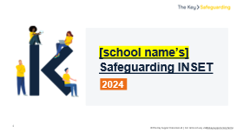 | - In advance: adapt the slide notes and the slides where the slide notes say to do so  - On the day: make sure you have a copy of the facilitator notes, either printed or open on a separate device. Have your safeguarding system or form for reporting concerns open, so you can show it to staff during the session and answer questions about it  [In advance, edit this slide to include your school’s name.]  - Welcome staff to your 2024 safeguarding and child protection INSET  - Let staff know there will be interactivity throughout the session, with videos, quick questions, scenarios and group discussions
2 | 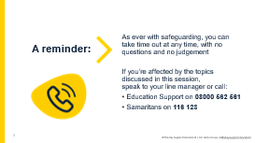 | - Remind staff that they can leave for a moment at any point, but that safeguarding training is mandatory and if they’re able to return, they should
3 | 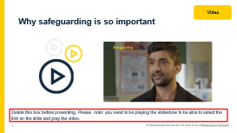 | [Please note: you need to be playing the slideshow to be able to select the link on the slide and play the video.]  - Tell staff this short video shows why today’s training is so important, and ask them to give the video their full attention  - Play the video (2:24)  - Note afterwards that the designated safeguarding lead (DSL) is played by an actor, but the story is real  - Add that there have been a number of harrowing news stories in the last couple of years about children who have suffered and been murdered or died in abusive circumstances. For example, staff are likely to have seen news stories about Arthur Labinjo-Hughes, who was murdered by his father and stepmother, or Logan Mwangi, who was murdered by his mother, her partner and a teenager. In another case, a toddler, Star Hobson, was murdered by her mother’s partner after months of abuse. Her mother was also convicted of causing or allowing her death. The ultimate aim of this training, and what we’re doing every day, is to stop that happening here  - Video source: https://vimeo.com/962095580/57dd79ec62
4 | 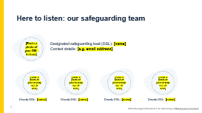 | [In advance, edit this slide to include details of your school’s safeguarding team, as set out on the slide. If anyone works part-time, you might want to include what days they work as well.]  - Explain that if staff have concerns (examples of which will be discussed in this session), they need to report it to your school’s safeguarding team  - Your safeguarding team has particular responsibilities for safeguarding, beyond the responsibilities that all staff have  - Explain that the people on the slide make up your school’s safeguarding team  - Briefly talk through each person and their responsibilities  - Remind staff that the safeguarding team can support staff as well as pupils
5 | 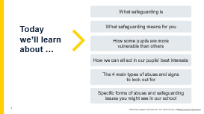 | - Run through the learning objectives with staff  - Acknowledge that some of what you’re covering today might feel familiar, but it’s a key part of what you do as a school
6 | 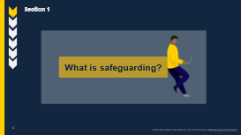 | - Tell staff that first, you’re going to look at what safeguarding is and how safeguarding is a crucial part of what you do as a school
7 | 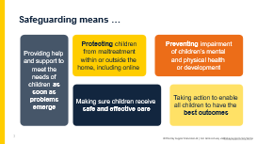 | - Explain that to effectively safeguard children, we need to know what we mean by the term ‘safeguarding’  - Essentially, safeguarding means protecting children from harm, so they can grow up safe, happy and healthy  - Remind staff that children are children until they are 18  - Select to bring up each element in turn. In more detail, safeguarding means:  - Providing help and supporting to meet the needs of children as soon as problems emerge  - Protecting children from maltreatment, whether that is within or outside the home, including online  - Preventing impairment of children’s mental and physical health or development  - Making sure children receive safe and effective care as they grow up  - Taking action to enable all children to have the best outcomes  - The definition of safeguarding on the slide is set out in Keeping Children Safe in Education and has been updated slightly this year – the line ‘Providing help and support to meet the needs of children as soon as problems emerge’ is completely new, and there’s an addition to the line about protecting children from maltreatment to clarify that it’s ‘within or outside the home, including online’  - You’ll look at other changes to the guidance in later slides
8 | 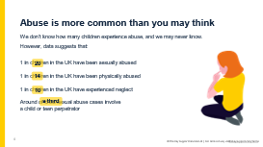 | [Please note, when you preview this slide, the answers will already be on the screen. When you play the slideshow, they’ll appear when you select to bring them up.]  - Get staff to look at the different statistics on screen and think about what the figures might be in the blank yellow boxes. Let them discuss with the person sitting next to them for a couple of minutes  - Ask for some suggestions for each line before selecting to reveal the statistics one by one  - Where appropriate, put these figures in terms of your school size. For example:  - If your school has 200 pupils, explain that 1 in 20 is the equivalent of 10 of your pupils having been sexually abused – and 3 of those may have involved a child or teen perpetrator  - Highlight that for the last statistic, it’s important to remember that child or teen perpetrators of abuse may well also be victims of abuse in their own right  - Emphasise that many children do not report abuse ever, and that these figures are simply an estimate based on research data
9 | 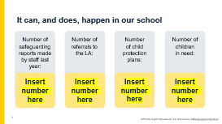 | [In advance, edit this slide to reflect your school’s context. Make sure children can’t be identified from the numbers you’re sharing. For example, if there’s only 1 child protection plan and it’s likely that staff members would be able to guess which child it’s for, delete this box and don’t include this point.  If your data from last year shows lower numbers than usual, you could edit the slide to show combined totals for the last 2 or 3 years instead, to encourage staff to take notice.]  - Explain that now that we’ve seen some national statistics in the previous slide, you’re going to look at your school’s context  - Select to bring up what each statistic refers to  - Briefly talk staff through the information on the slide
10 | 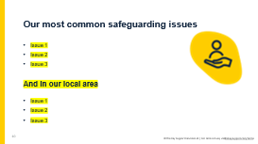 | [In advance, edit this slide to list the most common safeguarding issues that you have come across in your school, and in your local area (if you feel these are different from issues in your school and worth mentioning separately).  If there have been any safeguarding issues that your staff might not expect to happen at your school, you could highlight these, as well as the most common issues.  Be mindful of confidentiality – if you feel you cannot summarise common issues without identifying a particular child or children, don’t mention them.]  - Go through the common issues in your school one by one, in particular pointing out those that may be unexpected or hard to spot  - Optional: highlight any common safeguarding trends in your local area that you want staff to be aware of, especially if they haven’t been mentioned as a common issue in your school  - Your LA may be able to help provide some information on this if you’re not aware of the main issues in your local area, outside of your school
11 | 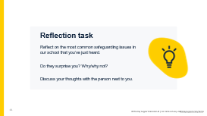 | [Optional reflection task. Delete this slide if you need a shortened version of this section.]  - This reflection task is ‘think, pair, share’ style. Ask staff to take a moment in silence to reflect on the safeguarding issues you’ve just discussed, and whether they find those surprising or not, and why  - Then, ask them to discuss their thoughts with the person next to them  - Invite staff to share their thoughts with the room. Take 1 or 2 responses

SECTION 2: WHAT DOES SAFEGUARDING MEAN FOR ME?
Time: 10 minutes without optional reflection task, 12 to 15 minutes with reflection task.
Resources required: n/a
12 | 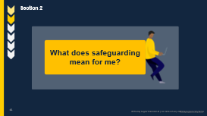 | - Tell staff that now, you’re going to cover any relevant changes to Keeping Children Safe in Education (KCSIE), the roles in a school that have safeguarding responsibilities, and what signs of concern to look for in pupils
13 | 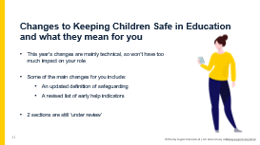 | [In advance, decide whether you want your staff who don’t work directly with children to read part 1 of Keeping Children Safe in Education (KCSIE) or the condensed version in Annex A. Update the first bullet point below accordingly.]  - Explain that all staff need to read part 1 of Keeping Children Safe in Education OR all staff who work directly with children need to read part 1 of Keeping Children Safe in Education, and staff who don’t work directly with children need to read Annex A of the guidance  - Explain that this year’s changes are mainly technical, and so won’t have much of an impact on the role of staff. We’re expecting bigger changes in the 2025 version  - Select to bring up each change in turn and explain what it means for staff  - The definition of safeguarding has been expanded to bring it in line with Working Together to Safeguard Children. A new line has been added: ‘Providing help and support to meet the needs of children as soon as problems emerge’. And in the bullet on protecting children from maltreatment, the guidance now clarifies that this is ‘within or outside the home, including online’  - There are also updates to early help indicators. You should now also be alert to any child who:  - Has experienced multiple suspensions, is at risk of being permanently excluded from schools, colleges and in alternative provision or a pupil referral unit  - Has a parent or carer in custody (previously it was 'family member in prison'), or is affected by parental offending  - Is frequently missing/goes missing from education, home or care (the word ‘education’ has been added)  - 2 sections of KCSIE are still under review – we’re not sure whether they’ll be finalised for the publication of the final version of the guidance on 1 September. One of these changes is the section in Annex B on ‘preventing radicalisation’, following the government’s new definition of extremism earlier this year. The other section is in part 2, on ‘lesbian, gay, bisexual and gender questioning children’, which we’ll cover on the next slide
14 | 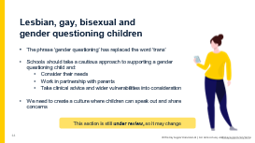 | - The section on children who are lesbian, gay, bisexual or gender questioning has been updated, but for now it remains under review until the response to the gender questioning children consultation and final guidance have been published  - The phrase 'gender questioning' has replaced the word 'trans’  - This section reflects some of the findings of the Cass review, such as that:  - Caution is necessary for children questioning their gender as there are still unknowns around the impact of social transition, and that children may have wider vulnerability, including complex mental health and psychosocial needs, and in some cases, autism spectrum disorder and/or attention deficit hyperactivity disorder  - When families/carers are making decisions about support for gender questioning children, they should be encouraged to seek clinical help and advice. This should be done as early as possible when supporting pre-pubertal children  - KCSIE says schools should take a cautious approach to support a gender questioning child and:  - Consider the broad range of the individual's needs  - Do this in partnership with their parents (except in rare circumstances where involving parents would bring a significant risk of harm to the child)  - Include any clinical advice that is available  - Consider how to address wider vulnerabilities, such as the risk of bullying  - If and when guidance on gender questioning children, and/or any updated version of KCSIE, is published, you should refer to that guidance when deciding how to proceed. (In the meantime, you shouldn't make any changes to your policies and procedures in response to the draft gender questioning children guidance. You must, of course, continue to fulfil your legal duty to protect and support your trans pupils and staff)  - It's also important for staff to 'create a culture' where pupils can speak out or share any concerns with staff (previously it was to 'provide a safe space' for pupils to do this)
15 | 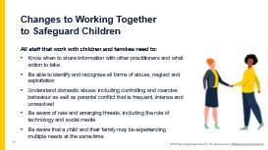 | - Working Together to Safeguard Children was updated at the end of 2023  - Explain to staff that Working Together to Safeguard Children is a piece of statutory guidance that sets out how local authorities (LAs), partner agencies and organisations should work together to safeguard and promote the welfare of all children. Although education settings must follow the guidance, not all of the updates will be relevant to staff – some will be more relevant for the designated safeguarding lead (DSL) and senior leaders, and some not relevant to schools at all  - Read out the new safeguarding training requirements:  - Know when to share information with other practitioners and what action to take to support early identification and assessment  - Be able to identify and recognise all forms of abuse, neglect and exploitation  - Understand domestic abuse, including controlling and coercive behaviour as well as parental conflict that is frequent, intense and unresolved  - Be aware of new and emerging threats, including online harm, grooming, sexual exploitation, criminal exploitation, radicalisation, and the role of technology and social media in presenting harm  - Be aware that a child and their family may be experiencing multiple needs at the same time  - Emphasise that most of these are not new and are already covered by KCSIE. Highlight the new reference to ‘parental conflict’, which is not part of KCSIE – we’ll discuss it on the next slide to make sure staff know what it is
16 | 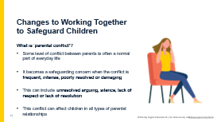 | - Explain that this is the government’s definition of parental conflict  - Emphasise that conflict in itself is not a safeguarding concern, but conflict that is frequent, intense, poorly resolved or damaging can be, as it can have a significant negative impact on children’s mental health and long-term life chances  - Explain to staff that they may hear about parental conflict:  - Directly from a child  - Through a child’s work, such as written work in English  - Through a child’s actions during play  - From parents during parents’ evening or other meetings  - Remind staff that parental conflict at home can lead to other behaviours in school – for example, a child could be more withdrawn or angrier. Tell staff they’ll hear more about these warning slides later in the session  - Remind staff that there are many reasons for parental conflict. Ask staff to identify some – answers could include poverty, cost of living, illness, etc.  - Emphasise that parental conflict in general is not a safeguarding concern, but can be a warning sign if it becomes frequent or intense
17 | 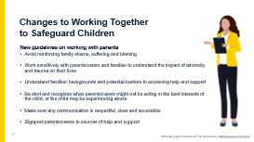 | - Explain that there are new guidelines on working with parents and carers, so if staff do so, they should:  - Avoid reinforcing family shame, suffering and blaming  - Work sensitively with parents/carers and families to understand the impact of adversity and trauma on their lives  - Understand families’ backgrounds and potential barriers to accessing help and support  - Be alert and recognise when parents/carers might not be acting in the best interests of the child, or the child may be experiencing abuse (and follow your school’s policies and procedures)  - Make sure any communication is respectful, clear and accessible, adapted to the parents/carers’ needs, and makes use of translations or interpreters where necessary  - Signpost parents/carers to sources of help and support available locally and through your LA, and make sure they’re aware of support that’s available when meeting with the school (e.g. they can bring a friend/family member with them)
18 | 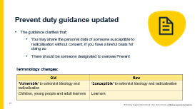 | - The Prevent duty guidance was updated in autumn 2023  - Explain that there are no additional responsibilities for schools – the guidance instead makes some clarifications for schools  - Go through the slide:  - Explain that the guidance clarifies that you may share the personal data of someone susceptible to radicalisation without consent, if you have a lawful basis for doing so – as we know, UK GDPR does not prevent the sharing of information for the purposes of keeping children safe and promoting their welfare  - Someone should be designated to oversee Prevent – your school is likely already doing this with your DSL  - There are also some terminology changes. There’s a difference between vulnerable and susceptible – not all people susceptible to radicalisation will be vulnerable, but a person’s vulnerabilities can make them more susceptible to radicalisation. A person can be vulnerable because they need special care, support or protection because of age, disability, risk of abuse or neglect. For example, learners who are vulnerable to grooming for sexual exploitation, criminal exploitation or county lines, may also be vulnerable to radicalisation  - Explain that staff will have separate, in-depth Prevent training, as they should be trained specifically on Prevent
19 | 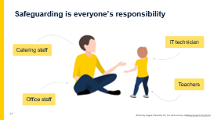 | - Explain that you’re now going to see how every member of staff can play a role in safeguarding children  - Select to bring up the different roles one by one  - Acknowledge that you can’t cover every role in school in the time you have today, and ask staff to find the role closest to their own on the slide. Ask staff to think about what they, in their role, might notice about a child that could be a cause for concern  - Take some feedback from staff. Highlight:  - Catering staff will see pupils interacting with each other outside class and overhear conversations. They might notice who’s eating more or less, or children stealing food  - Office staff might notice high levels of absence, pupils who are often late, and/or parents and carers who are tricky to get hold of or respond to requests from the school  - IT technicians will see what pupils are searching for and trying to access  - Teachers might notice children doing less well at school, changes in their behaviour, and other small changes over time  - Taken on their own, these things might not seem like much. But, if staff report them, you (the DSL) can start to build a picture. Their piece of information could be the final piece of the puzzle that helps you (the DSL) to make a referral to children’s social care
20 | 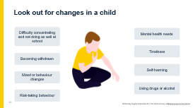 | - Say that now we've seen that everyone has a role to play and we must always act on concerns, we’re going to look at the common signs that should always be a cause for concern  - Ask staff: what have you previously seen that led to you making a report? If you haven’t made a report, what sort of things might you see that should make you worried about a child? Take a few suggestions from staff then select to bring up the signs and talk through them  - Select to bring the signs up in turn:  - Difficulty concentrating and not doing as well at school  - Mental health needs – this could be signs of depression, anxiety, eating disorders or post-traumatic stress disorder, for example. Tell staff you’ll cover common signs of mental health needs to be alert to later in this session  - Becoming withdrawn  - Tiredness  - Mood and behaviour changes – for example, becoming more irritable, angry, aggressive or clingy; attention-seeking behaviour or ‘acting out’  - Self-harming – this could include disordered eating  - Risk-taking behaviour – this could include behaviour such as stealing, bullying, running away, sexual activity, trespassing or vandalism, fighting, or truancy  - Using drugs or alcohol, especially if they didn’t before  - Note these signs are common across multiple different safeguarding issues and types of abuse  - Emphasise that:  - The key thing to look for is a change in the child. Staff don't need to 'diagnose' an issue or know exactly what it might be, just notice that something might be wrong and act. It’s for others to investigate what the issue might be  - Children can try to communicate that something is wrong through their behaviour, either intentionally or unintentionally  - Staff should be professionally curious about what might be behind the change they’re seeing  - Some of these signs might be innocent – for example, a child might experience mood swings as they go through puberty – but they should always be reported
21 | 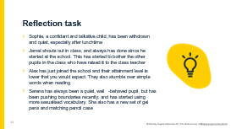 | [Optional reflection task. Delete this slide if you need a shortened version of this section.]  - Ask staff to look at the 4 examples and think about whether there should be a safeguarding referral made. They should discuss this with the person next to them  - Take some feedback from staff  - Highlight that Jamal and Alex might have some unmet SEN needs, but that these examples alone wouldn’t suggest any safeguarding concern  - Identify that Sophie and Serena’s behaviours have changed, which should flag concern, but don’t necessarily mean there is definitely a safeguarding issue
22 | 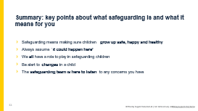 | - Explain that you’ve now covered the first 2 learning objectives  - Ask staff: what are the key points to take away about the importance of safeguarding?  - Take 1 or 2 suggestions, then select to bring up the points on the slide  - Give staff a minute to read these key points  - Ask if they have any questions about what you’ve covered so far

SECTION 3: SOME PUPILS ARE MORE VULNERABLE THAN OTHERS
Time: 8 minutes without optional reflection task, 9 to 10 minutes with reflection task.
Resources required: n/a
23 | 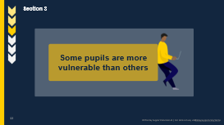 | - Tell staff that now, you’re going to look at how some pupils are more vulnerable than others
24 | 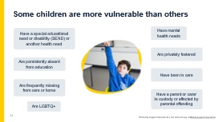 | - Tell staff that while all children are vulnerable to abuse, there are some we need to pay particular attention to, as they're more vulnerable than others  - Select to bring up the groups of pupils who are more likely to need early help or may be at greater risk of harm, and run through them. These are pupils who:  - Have special educational needs or disabilities (SEND) or have certain health conditions and specific additional needs  - Have a mental health need  - Are persistently absent from education, including absences for part of the school day  - Are privately fostered  - Are frequently missing from care or home  - Are lesbian, gay, bisexual, transgender, queer or questioning (LGBTQ+), or perceived to be  - Have a parent or carer in custody, or are affected by parental offending  - Have returned home to their family from care  - Explain that there are further groups of pupils who are more vulnerable to abuse on the following slide
25 | 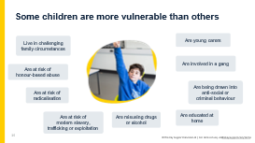 | - Explain that this slide is a follow-on from the previous slide, listing further groups of pupils who are more vulnerable to abuse  - Select to bring up the groups of pupils who are more likely to need early help or may be at greater risk of harm, and run through them. These are pupils who:  - Are in challenging family circumstances – for example, drug and alcohol misuse, adult mental health issues and domestic abuse  - Are young carers  - Are at risk of honour-based abuse, such as forced marriage or female genital mutilation (FGM)  - Are showing signs of being drawn into anti-social or criminal behaviour, including gang involvement and association with organised crime or county lines  - Are at risk of being radicalised or exploited  - Are at risk of modern slavery, trafficking, sexual or criminal exploitation  - Are misusing drugs or alcohol  - Are educated at home and therefore less visible to the services that are there to keep them safe and supported in line with their needs  - Note that early help means providing support as soon as a problem emerges at any point in a child’s life, from the foundation years through to the teenage years
26 | 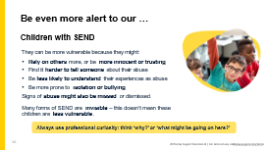 | - Tell staff you're going to look at a particular group in more detail now: pupils with special educational needs and disabilities (SEND)  - Highlight that children with disabilities are over 3 times more likely to be abused than other children  - Explain they're more vulnerable as they might:  - Rely on others for assistance and care, giving abusers more opportunities to abuse them. They might be more prone to trusting others, and/or naïve when it comes to abusive behaviour. For example, they may be more likely to believe lies told to them by strangers on the internet, or more likely to assume that an abusive family situation is normal  - Find it harder to communicate their abuse. This could be due to communication barriers caused by speech, language and communication needs, or because they’re more isolated and have fewer opportunities to tell someone about abuse  - Be less likely to understand that what they're experiencing is abuse. This doesn’t mean they aren’t harmed by abuse though – they are still experiencing harm  - Be more prone to isolation and/or bullying by their peer group due to their SEN or disability  - Signs of abuse can also be missed, as they're seen as symptoms of their SEN or disability, or caused by their SEN or disability. For example, bruises might be assumed to be caused by disability equipment or problems with mobility. Or, children experiencing abuse or attempting to tell someone about their abuse might self-harm or display inappropriate sexual behaviour, or other repetitive or challenging behaviours, which are misinterpreted as part of their needs or disabilities  - Remind staff that:  - All forms of SEND are different, and even 2 pupils with the same form of SEND may have very different strengths and weaknesses. All of these risk factors may or may not be true for any particular individual  - SEND is more than the stereotyped use of wheelchairs and blind/deafness – a lot of SEN and disabilities are invisible, and it can be easy to forget that these children are also more vulnerable. For example, neurodivergent pupils can be particularly good at ‘masking’, where they hide their struggles and act as though everything is fine when it’s really not  - Give staff an example. Either use an (anonymous) example from your context if you have one, or share the example below:  - In 1 serious case review, a 13-year-old boy – Harry – was the victim of criminal exploitation  - Harry was diagnosed with a developmental disability in early childhood, and he struggled with his behaviour throughout primary school due to his disability  - This led to regular periods of exclusion from school  - Harry was desperate to fit in with his peers, which made him particularly vulnerable to exploitation  - Harry ended up involved in a serious violent crime due to exploitation by older children who he wanted to fit in with and be part of the ‘gang’  - So, what should staff do?  - Be even more alert to children with SEND and any signs that something might be wrong  - Always use professional curiosity. Think 'why?' or 'what might be going on here?’
27 | 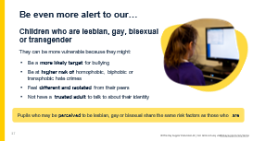 | - Tell staff you're going to look at another particular group in more detail now: pupils who are, or are perceived to be, LGBTQ+ (lesbian, gay, bisexual, transgender, queer and/or questioning)  - Highlight that nearly half of LGBTQ+ children experience bullying in school, and 1 in 10 find themselves having to leave their family home due to their sexuality or gender identity  - Explain they may be more vulnerable as:  - They may be a more likely target for bullying and/or hate crimes related to their sexuality and/or gender identity. News stories and campaigns by famous figures such as JK Rowling may increase the level of targeted attacks  - They may be aware that they are in some way different from their peers, or that they don’t fit in, and can’t be themselves  - They may not be ‘out’ to friends or family, and may be worrying about coming out at home or to their friends. If they’re worried about coming out to family, it’s likely that they don’t have a trusted adult to share their concerns with  - Emphasise to staff that pupils don’t need to be lesbian, gay or bisexual to be subject to bullying. They may still be on the receiving end of this abuse if they are perceived to be lesbian, gay or bisexual, regardless of their own identity
28 | 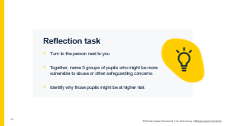 | [Optional reflection task. Delete this slide if you need a shortened version of this section.]  - Allow staff a couple of minutes for this discussion-based task
29 | 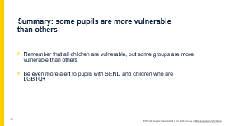 | - Explain that you’ve now covered the first 2 learning objectives  - Ask staff: what are the key points to take away about the importance of safeguarding?  - Take 1 or 2 suggestions, then select to bring up the points on the slide  - Give staff a minute to read these key points  - Ask if they have any questions about what you’ve covered so far

SECTION 4: HOW we can all ACT IN our pupils’ BEST INTERESTS
25 minutes
Time: 25 minutes, plus 5 minutes for optional discussion tasks
Resources required: staff activity packs
30 | 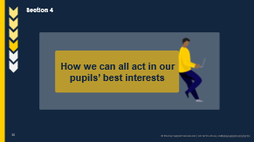 | - Tell staff you're now going to look at how to act in the best interests of the pupils in your school, and what your safeguarding responsibilities mean in practice  - In this section you’ll cover:  - What to do if a child makes a disclosure  - The ways in which children communicate abuse  - Writing safeguarding reports
31 | 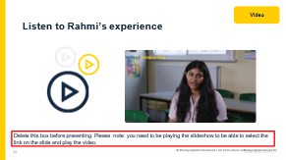 | [Please note: you need to be playing the slideshow to be able to select the link on the slide and play the video.]  - Remind staff that children might not know how to, or be ready to, report or even speak about abuse  - Children might not tell someone about abuse because they:  - Don’t recognise their experiences as harmful  - Are ashamed or embarrassed  - Have been threatened (or a family member has been threatened)  - Are being blackmailed  - Are worried about not being believed or about what might happen next  - Feel they don’t have anyone to turn to  - Are worried that they might get a family member in trouble  - Disabilities, sexual orientation, vulnerabilities and language barriers might also affect children’s ability or willingness to talk about abuse  - In particular, younger children might not have the language to describe their abuse  - It’s important staff can respond appropriately if a child does tell them about abuse, so we’re going to spend some time looking at this now. We’re going to start by watching a video where you see a child tell an adult about a harmful experience they’re in  - Note afterwards that the video has been voiced by an actor, but the story is real  - Play the video (2:14)  - Video source: https://vimeo.com/962069252/6f5bd831a2
32 | 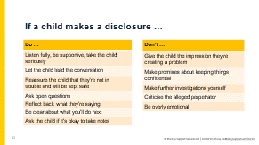 | - Ask staff: imagine they’re the adult hearing this from Rahmi. What should they do now?  - Take some feedback from staff  - Select to bring up the ‘dos’ on the slide and talk through them. Make sure to draw out any points that staff didn’t mention in their feedback  - Listen fully, be supportive and take Rahmi seriously  - Let her lead the conversation – it might be tempting to interrupt during any pauses, but don’t  - Reassure Rahmi that she won’t get into trouble for sharing the information, and that she’ll be kept safe  - Ask open questions, not closed or leading questions  - Reflect back what she’s saying, to check your understanding and make it clear you’re interested in what she’s telling you  - Be clear about what happens next – including who you’ll need to tell – but reassure Rahmi that you’ll only talk to people who really need to know  - If you need to take notes, ask the child if they’re comfortable with that first  - Select to bring up the ‘don’ts’ on the slide and talk through them. Make sure to draw out any points that staff didn’t mention in their feedback  - Don’t give Rahmi the impression that she’s creating a problem by telling you about what’s happened  - Don’t promise confidentiality – be honest that you’ll need to tell someone else  - Don’t try and gather further information from other parties involved – don’t go and talk to Rahmi’s mum. It’s your (the DSL’s) job to co-ordinate what happens in response to safeguarding concerns and allegations of abuse. If staff confront the alleged abuser (in this case, Rahmi’s mum) themselves or try to investigate it, they could make things worse for the child  - Don’t criticise the alleged perpetrator – this can make the situation more emotionally charged for the child  - Don’t be overly emotional – this can make it more difficult for the child to make a disclosure. Be supportive but as calm as possible
33 | 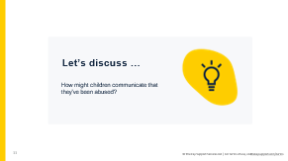 | [Optional reflection task. Delete this slide if you need a shortened version of this section]  - Give staff 2 minutes to discuss the question in small groups or pairs, and to try and think of 2 or 3 answers  - Once the time is up, ask someone from each group to give an answer
34 | 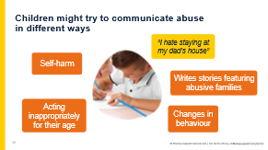 | - Tell staff that children might also try to tell someone about their abuse indirectly. This is sometimes known as an ‘indirect disclosure’  - Say you’re going to look at a made-up example now  - Select to bring up the different ways Jackson might try to tell someone about abuse indirectly. He might:  - Make ambiguous verbal statements, such as “I don’t want to stay there” and “Grandpa’s snoring keeps me awake at night”  - Communicate through his behaviour – for example, self-harming, becoming withdrawn or ‘acting out’ to try to communicate his distress  - Communicate non-verbally – for example, writing a letter or drawing pictures  - Act inappropriately for his age – for example, sexual language and behaviour in younger children might be a sign of sexual abuse  - Changes in behaviour – changes in behaviour or mood can indicate a concern, such as attention-seeking behaviour or being more withdrawn and quieter than usual  - Tell staff they should be on the lookout for these behaviours  - If they notice any, they should ask the child if everything is okay and chat to them about the behaviour they’ve noticed, and/or ask another member of staff who the child trusts to do the same  - If in doubt, they could talk to you (the DSL) about the best way forward  - This might lead to children telling them directly about abuse they’ve experienced, which will help you get the child the help they need
35 | 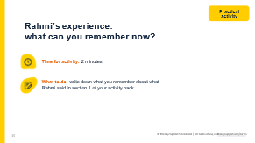 | - Ask staff to take 2 minutes to write down, individually, what they remember about what Rahmi said in the video  - There’s space for them to do this in section 1 of their activity packs
36 | 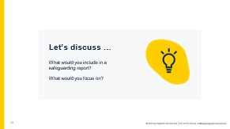 | [Optional discussion task. Delete this slide if you need a shortened version of this section.]  - Give staff 2 minutes to discuss the question in small groups or pairs, and to try and think of 2 or 3 answers  - Once the time is up, ask someone from each group to give an answer
37 | 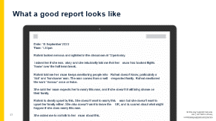 | - Take feedback from staff about what they remember  - Select to reveal the report on the slide and give staff a minute to read it – tell staff that you’ll break down what makes this report good in the next slide  - Explain that the slide shows a model report. This is the level of detail staff should be writing down – whether it’s an allegation of abuse or reporting a safeguarding concern  - Ask staff to reflect on how much they remembered, and how accurately they remembered it. Did they forget any details, or misremember anything?  - Emphasise that they should always make a report immediately afterwards, or as soon as possible if they can’t do it immediately, so their report is as accurate as possible  - Where they can’t make the report immediately, it’s crucial to hold the key details of who, what, where and when in mind  - Highlight that:  - Poor record keeping is often mentioned in serious case reviews  - Their report may be used as part of a statutory assessment process, or as evidence in court. Not keeping accurate records can stop children getting the help they need
38 | 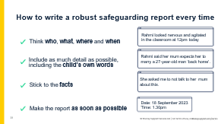 | - Ask staff: what was good about the report on the previous slide?  - Take suggestions from 1 or 2 members of staff  - Select to bring up the points on the slide with the examples from the report to illustrate the point. A good safeguarding report:  - Gives details of who, what, where and when  - Describes what happened in detail, and includes the child’s own words where possible  - Is based on facts. It doesn’t include any interpretation of what happened or opinions  - Is made as soon as possible after the incident – whether that incident is a member of staff noticing something, or a child telling them about abuse  - Keep the record up to date with details of how the concern was followed up and resolved, and any action taken, decisions reached and the outcome  - After revealing the points, ask staff to discuss with the person next to them what they wrote down earlier in their activity pack, and how well it compares to the 4 key things to include in a safeguarding report
39 | 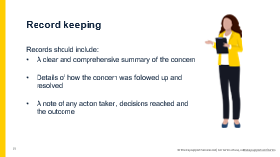 | - As well as making a robust initial report, follow-up records also need to be kept up to date  - KCSIE says that all concerns, discussions and decisions made, and the reasons for those decisions, should be recorded in writing  - Records should include:  - A clear and comprehensive summary of the concern  - Details of how the concern was followed up and resolved  - A note of any action taken, decisions reached and the outcome  - If staff are not sure about what they need to record, they should talk to you (the DSL)
40 | 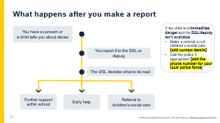 | [In advance, edit this slide to include the contact details for your local children’s social care team, and your local police force.]  - Talk through what happens when staff report concerns. Explain it through an example child called Liam. Select to reveal each point as you make it  - A member of staff has a safeguarding concern about Liam, or Liam tells them about abuse that’s happened to him  - If they think Liam is in immediate danger and you (the DSL) or deputy (or another member of the senior leadership team) isn’t available, they can make a referral to the local authority’s children’s social services themselves, and contact the police if appropriate  - Immediate danger means that Liam is suffering harm or is likely to suffer harm  - To decide whether Liam is in immediate danger, staff should ask themselves: if I don’t do something now, will he come to harm? (Note that this will always be subjective)  - Staff should still tell you (the DSL) or deputy as soon as possible after making a referral  - In most cases though, staff will make a report to you (the DSL) first  - Reiterate that their job isn’t to investigate, just to report  - You (the DSL) will then decide what to do next  - Liam might receive support within school, using your school’s own pastoral support processes  - Liam and his family might receive early help  - You (the DSL) might make a referral to the LA children’s social care team. If the LA makes a statutory assessment for a child in need plan or child protection plan, staff might be involved in the assessment. If so, you (the DSL) will support the staff member with this  - If staff don’t hear about what happened next, they should follow up with you (the DSL)
41 | 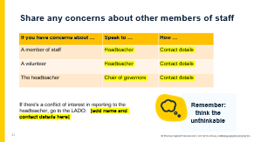 | [In advance, edit this slide to include the names and contact details of your head and chair of governors, and the contact details of your local authority designated officer (LADO). Edit the slide notes below to include details of your LADO.]  - Highlight that as well as safeguarding issues outside school, we need to be aware of the potential for abuse in school by staff:  - We need to ‘think the unthinkable’ – staff and volunteers may also abuse pupils  - We should always report any concerns we have  - Tell staff that they should report anything where a member of staff has done, or they think they might have done, any of the following:  - Behaved in a way that has harmed a child, or may have harmed a child  - Possibly committed a criminal offence against or related to a child  - Behaved towards a child or children in a way that indicates they may pose a risk of harm to children  - Behaved or may have behaved in a way that indicates they may not be suitable to work with children  - Tell staff how to report allegations against other staff members  - Make sure you cover who to report to, which will depend on who the concern is about, and how to report  - Explain that concerning behaviour outside of school should also be reported  - Highlight that supply staff, contractors and volunteers are also covered by your procedures for handling allegations and safeguarding concerns  - Mention that if there is a conflict of interest in reporting an allegation to the headteacher, staff should report it directly to the LADO: [insert contact details]
42 | 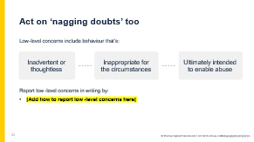 | [In advance, edit this slide to set out how staff should report low-level concerns.]  - Explain that low-level concerns are concerns where the behaviour of an adult in your school doesn’t follow your staff code of conduct, including inappropriate conduct outside of work, but the behaviour doesn’t meet the ‘harm’ threshold or isn’t serious enough to refer to the LADO  - Low-level concerns are part of a spectrum of behaviour, from inadvertent or thoughtless behaviour or behaviour that seems inappropriate, to behaviour ultimately intended to enable abuse  - Give examples for each of the ‘bubbles’ on screen:  - Inadvertent or thoughtless – a member of staff sends a pupil out of the classroom to deliver a note to the office. The child does not return after a few minutes, but the member of staff doesn’t note this and makes no effort to find out where they’ve gone  - Inappropriate for the circumstances – a teacher shows pupils photos from their private Instagram page, revealing their username  - Intended to enable abuse – a teacher asks a pupil for their mobile phone number in order to send sexualised messages outside of work hours  - Give an example:  - The report from the Independent Inquiry into Child Sexual Abuse talks about a teacher who had ‘favourites’  - There were more than 20 incidents where favouritism, tactile behaviour or other unusual behaviour with young female pupils was observed, but wasn’t reported  - The teacher was later charged with 36 separate offences against children under 13 – the youngest child was 6  - There’s evidence that in the many years he worked at the school, he would choose a ‘favourite’ who was often vulnerable in some way. He then sexually abused the child, including in school  - Essentially, if staff feel uneasy or uncertain about another member of staff’s behaviour towards or around children, they should report it. Just because it doesn’t meet the ‘harm’ threshold doesn’t mean it’s insignificant or not worth acting on  - Small concerns can help to build a picture  - In the previous example, 1 adult had said they thought the teacher’s behaviour was ‘a bit close for comfort’  - Staff should ask themselves whether anything feels off or ‘a bit close for comfort’ for them – and report anything that bothers them  - Highlight any differences in allegations procedures for reporting low-level concerns that staff need to know about  - Remind staff that these procedures also cover concerns about supply staff, volunteers and contractors  - Remind staff to make written records
43 | 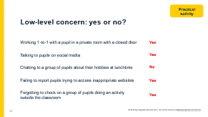 | [Please note, when you preview this slide, the answers will already be on the screen. When you play the slideshow, they’ll appear when you select to bring them up.]  - Select to bring up each potential low-level concern in turn  - Ask staff: is this a low-level concern?  - Take 1 or 2 responses for each, then select to bring up the answer  - 4 of these are low-level concerns, as while no harm has been committed, the behaviour in each is inappropriate, inadvertent or thoughtless, or could be ultimately intended to enable abuse
44 | 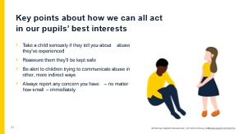 | - Ask staff: what are the key points to take away about how to act in a child’s best interests?  - Take 1 or 2 suggestions, then select to bring up the points on the slide  - Give staff a minute to read these

SECTION 5: the 4 main types of abuse and signs to look out for
25 minutes
Time: 25 minutes
Resources required: staff activity packs
45 | 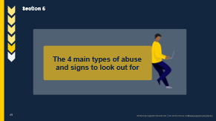 | - Tell staff you’re now moving on to the next learning objective. You’re going to look at the 4 main types of abuse and how to spot them, so staff can carry out their safeguarding duties more effectively
46 | 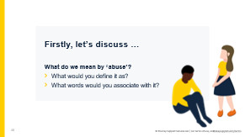 | [Optional discussion task. Delete this slide if you need a shortened version of this section.]  - First, ask staff what they think we mean by ‘abuse’  - Give them some prompts:  - What would they define abuse as?  - What words would they associate with it?  - Take answers from 1 or 2 members of staff
47 | 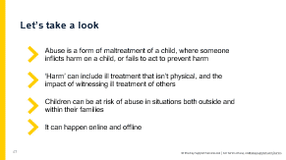 | - Explain that:  - Abuse is a form of maltreatment of a child, where someone inflicts harm on a child, or fails to act to prevent harm  - ‘Harm’ can include ill treatment that isn’t physical, as well as the impact of witnessing ill treatment of others – for example, witnessing domestic abuse in the household  - Children can be at risk of abuse in situations outside, as well as within, their families  - It can happen online and offline, and technology can be used to facilitate offline abuse
48 | 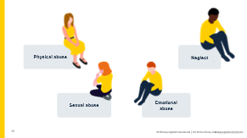 | - Explain that you’re going to look at 4 main types of abuse. These are:  - Physical abuse  - Sexual abuse  - Emotional abuse  - Neglect  - Emphasise that in most cases, multiple issues will overlap with one another  - The critical thing, though, is to be professionally curious and be able to spot that something might be wrong
49 | 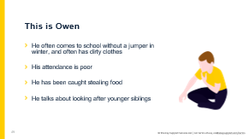 | - Introduce staff to Owen. Tell staff that:  - He often comes to school without a jumper in winter, and often has dirty clothes  - His attendance is poor  - He has been caught stealing food  - He talks about looking after younger siblings  - Owen also has younger siblings, who:  - Have often got rashes and infections, or head lice  - Often have dirty clothes, and their classmates complain they smell funny  - Are quite small for their age  - Often have cuts and scrapes (suggesting a lack of appropriate supervision)  - Have complained about toothaches, but never seems to get taken to the dentist  - Owen and his siblings are suffering from neglect, the first type of abuse we are looking at
50 | 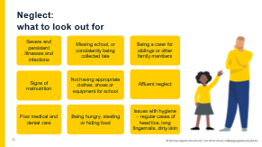 | - Clarify that it’s very unlikely that 1 child would have all these signs – in reality, a child would most likely only have a few signs. This is why we have to keep a very careful watch to spot the signs  - Explain:  - Neglect is when a parent or carer doesn’t meet their child’s basic physical and/or psychological needs, to the point that there are likely to be serious negative effects on the child’s health or development  - Neglect is the most common reason for a child protection plan  - It could involve:  - Not providing adequate food, clothing and shelter (including excluding the child from their home or abandonment)  - Failing to protect a child from physical or emotional harm or danger  - Not making sure a child has proper supervision  - Not getting medical care or treatment for a child  - Failing to meet or respond to a child’s basic emotional needs  - Explain that there’s also affluent neglect, which is the neglect experienced by children from wealthier families. It can be harder to spot and sometimes overlooked. Affluent parents may work long hours, leaving children unsupervised or with nannies, which can leave children feeling emotionally neglected. Wealthier parents may have a more relaxed attitude to alcohol, drugs and sexual activity, and colluded boundaries with their children. These parents may also have issues with alcohol or substance abuse, mental ill health, or domestic abuse – these issues can affect any type of family  - Explain that it can be hard to distinguish between neglect and material poverty. For example, a parent or carer might not be able to provide sufficient food, clothing or shelter due to poverty
51 | 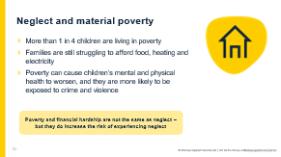 | - Highlight the fact that an increase in the number of families living in poverty has made it more difficult to spot signs of poverty vs neglect. Regardless, staff should report any concerns they have, as your school might be able to help the family  - Explain:  - 4.2 million children (more than 1 in 4) are living in relative poverty in the UK  - Research from the charity Barnardo’s says that the legacy of the cost-of-living crisis, along with benefit decreases due to inflation, will mean even more families will be living in poverty. As poverty rises, children and young people’s mental and physical health deteriorates and they are more likely to be exposed to crime and violence  - Parents and carers may feel shame and embarrassment about their financial difficulties, and may try to hide these issues from the school, so always keep an open mind and don’t assume that any particular family is okay, even if you believe they have an affluent lifestyle  - Remind staff again that being in poverty is not a safeguarding issue on its own, but it does increase the risk. It’s important to always report any concerns. The school can provide support for families struggling with the cost of living – but we need to know where to target that support
52 | 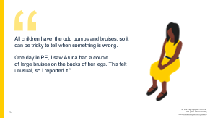 | - Explain that you’re now going to look at another type of abuse  - Read the quote on the slide out to staff. Explain that this an example of something they might see in school which signifies a child is suffering from physical abuse  - Explain that physical abuse is when someone causes physical harm to a child. This can take many forms, including:  - Hitting  - Shaking  - Throwing  - Burning or scalding  - Poisoning  - Drowning  - Suffocating  - In some rare cases, parents or carers might fabricate the symptoms of, or deliberately induce, illness in a child
53 | 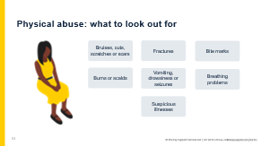 | - So, what might staff see in a child? Staff should note that if a child has regular injuries, there seems to be a pattern to their injuries or their explanations don’t add up, this should be reported. Select to bring up the signs in turn:  - Bruises, cuts or scratches  - Broken or fractures bones  - Bite marks  - Burns or scalds  - Other injuries or health problems, such as:  - Vomiting, drowsiness or seizures, which could be the effects of poisoning  - Breathing problems from drowning, suffocating or poisoning  - In cases of fabricated or induced illness: illnesses that are regular, doubtful or hard to explain, or only seen when the child is with the same adult(s)  - Children might also show changes in behaviour, such as:  - Being scared to go home  - Using their hair or fringe to cover marks  - Not wanting to do PE as they want to keep their skin covered  - Being more withdrawn, or having more outbursts
54 | 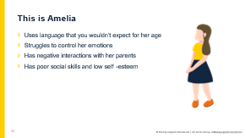 | - Explain that you’re now going to look at another type of abuse  - This is Amelia. She:  - Uses language that you wouldn’t expect for her age  - Struggles to control her emotions  - Has negative interactions with her parents  - Has poor social skills and low self-esteem  - Amelia is suffering from emotional abuse. Other signs that she might show are:  - Acting in a way, or knowing about things that you wouldn’t expect for her age  - Seeming to be isolated from her parents  - Being aggressive or hostile towards others, or bullying other children  - A delay in her language development
55 | 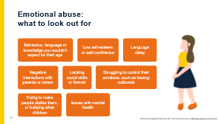 | - Tell staff that emotional abuse is any type of abuse that involves hurting a child emotionally, severely affecting their emotional development. It’s sometimes called psychological abuse  - It could involve:  - Making a child feel worthless, unloved or inadequate  - Silencing or making fun of what a child says  - Having inappropriate age or developmental expectations of a child. For example:  - Pushing them too hard or not recognising their limitations  - Limiting their learning  - Being overprotective  - Limiting their social interactions  - Exploiting or corrupting a child  - Serious bullying, including cyber-bullying  - Exposing a child to the ill treatment of another person – for example, domestic abuse  - Emotional abuse can be hard to spot, especially when it happens as part of other kinds of abuse  - Note that some level of emotional abuse is involved in all types of maltreatment
56 | 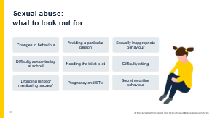 | - Explain that sexual abuse is the fourth main type of abuse, and it’s when someone forces or entices a child to take part in sexual activities, whether or not the child is aware of what is happening. This could be:  - Physical contact – for example, kissing, touching, rubbing (including outside clothes), or rape  - Non-contact abuse – for example, involving a child in looking at or producing sexual images, encouraging sexually inappropriate behaviour and grooming in preparation for child abuse  - Note:  - Adult males aren’t the only perpetrators of sexual abuse. Women can also commit sexual abuse, as can other children (you’ll look at abuse of children by other children in more detail later)  - It can happen online, offline, or both  - Select to bring up the signs as you go through them. Signs that staff might see are:  - Changes in behaviour, such as being aggressive, withdrawn or being tired in class due to sleeping difficulties and nightmares  - Avoiding their abuser(s) – they might seem afraid of a particular person and try to avoid spending time with them, or having poor personal hygiene to make themselves less attractive to their abuser  - Sexually inappropriate behaviour, such as using sexually explicit language or knowing things you wouldn’t expect them to  - Difficulty concentrating at school  - A pupil needing the toilet a lot, due to urinary tract infections (UTIs)  - Difficulty sitting, caused by soreness in the genital and anal areas  - Dropping hints or clues that the abuse is happening, without explicitly revealing it  - Pregnancy and STIs  - Being secretive online, or seeming distant, upset or angry after using their phone or the internet
57 | 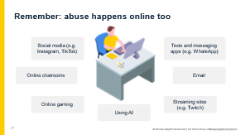 | - Explain:  - It can be very easy to assume that abuse happens in a physical space like the home or the classroom, but it’s important to remember that emotional and sexual abuse can also happen virtually  - This can include:  - Social media sites, such as X (formerly known as Twitter), Facebook, Instagram, TikTok, and Snapchat, as well as any other website where comments can be left on content a child has created (e.g. YouTube)  - Via email  - Using AI to generate harmful imagery, such as indecent images or to make fun of someone  - In online chatrooms, where children talk to each other virtually  - Texts and messaging apps, such as WhatsApp  - Streaming sites, where someone records themselves doing something live and can receive comments (e.g. gaming streaming on Twitch)  - Online gaming sites such as Roblox or Fortnite, where players can talk to each other while they play
58 | 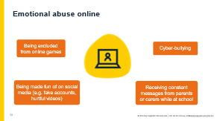 | - Explain that this slide and the next slide show some common ways that abuse can happen online, but this isn’t an exhaustive list. Any sort of abuse that comes from spoken word, coercion, etc. can be done online just as it happens in the ‘real world’  - Emotional abuse online may, for example, look like:  - Cyber-bullying, e.g. being teased or bullied via text, messenger apps, emails or comments  - Being excluded from things online, e.g. scheduled plans to play an online game together, or being repeatedly kicked out of an online game  - Making fake accounts or posting videos of a person with the intention of humiliating or embarrassing them  - Being constantly messaged by parents or caregivers while at school, to a degree that the child seems upset or unable to focus on schoolwork
59 | 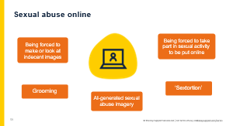 | - Sexual abuse online may, for example, look like:  - Being forced to look at indecent pictures or videos – e.g. by being sent them on messaging apps. This could include AI-generated content  - Being filmed or photographed during sexual activities and then having these images or videos put online  - Being befriended online by someone, with the intention of being groomed by them for further abuse, exploitation or trafficking – e.g. someone pretending to be a child of the same age on social media and convincing them to meet up, only to then commit further abuse  - ‘Sextortion’ – this is when an adult threatens to release nudes or semi-nudes of a child unless they pay money or do something to benefit them. Children of any age are potential targets, but older teenagers are particularly at risk  - Using AI to create indecent images of a child. For example, adults could use a photo of a child to generate a ‘deepfake’, which is where a photo or video of someone has been digitally altered so they appear to be someone else. These ‘deepfake’ images or video can be sexually explicit and are classed as child sexual abuse material  - A lot of these things can also happen as a form of child-on-child abuse. For example, children could create AI-generated images of another child
60 | 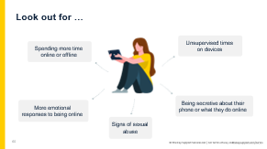 | - Explain that staff may notice the following signs of abuse being carried out online:  - The child may be spending more time online, or more time offline. This might be reported by their parents or carers. They might complain of being tired because they were online all night, or have their phone going off a lot  - They could have stronger emotional responses or outburst to being online – for example, the child may get unusually angry, upset or distant after checking their phone or using their computer/tablet  - Being secretive about their use of the internet or a device – they may refuse to hand their phone in if it’s part of school policy, or refuse to tell you what they get up to online  - The more general signs of sexual abuse that we saw earlier could indicate a child is being sexually abused online  - If a child tells you that they use their device unsupervised – for example, they play on their iPad when they go to bed – this could be a red flag  - As with other safeguarding issues, always look for changes in behaviour or mood. Although a change might not suggest a child is being abused online, the DSL will look into the situation further
61 | 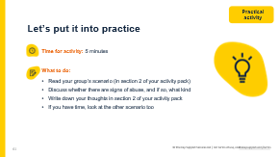 | [For this activity, we recommend 2 to 4 people per group. Give each group 1 scenario to discuss. When you take feedback, make sure you cover all the scenarios, so staff can hear the answers for each.]  - Tell staff they’re now going to look at some scenarios in groups to practise spotting potential signs of abuse  - Putting the learning into practice in a safe environment will help them use it in a real situation later on  - They’re going to look at 1 scenario in their groups (the scenarios are in section 2 of their activity packs)  - They have 5 minutes to read the scenario and discuss it, and write down their thoughts in section 2 of their activity packs  - Remind staff to consider the wider picture – could anything else explain what they’re seeing in the scenario?  - If they have time, they can look at the other scenario too  - Make sure staff know which scenario their group is looking at  - When the 5 minutes are up, get everyone back together and move on to the next slide
62 | 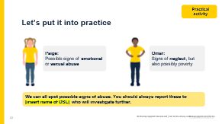 | [In advance, edit this slide to include your name.]  - Take feedback from 1 group for each scenario  - Once a group has given feedback on their scenario, select to bring up the answer on screen  - Confirm and clarify:  - Paige: a change in behaviour could be a sign of a safeguarding concern, no matter what it is. Being secretive with her phone could suggest emotional or sexual abuse online, along with her outburst – but this would need further investigation  - Omar: losing weight and not having any food could be a sign that Omar isn’t being given any food at home. This, combined with wearing dirty clothes to school, could suggest neglect. However, it could also be a sign of living in poverty, so the DSL would have to investigate the situation to find out why this is happening  - You can see that some of the signs might be the same across different types of abuse, so you can’t say for sure what’s happening in these scenarios  - Select to reveal the reminder: the main thing, though, is that staff can spot that something might be wrong. It’s for you (the DSL) to investigate further to find out what the cause might be
63 | 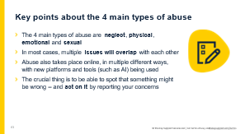 | - Ask staff: what are the key points to take away about the 4 main types of abuse?  - Take 1 or 2 suggestions, then select to bring up the points on the slide  - Give staff a minute to read these key points  - Ask staff if they have any questions about what you’ve covered so far

SECTION 4: specific safeguarding issues you might see in our school
20 to 60 minutes
Time: 25 minutes, plus around 5 minutes for each pick-and-choose slide you decide to use
Resources required: staff activity packs
64 | 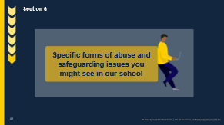 | [Before starting this section, decide which slides from the library of safeguarding issues you wish to cover with your staff, and delete any that you aren’t going to be using. You can always come back to this pack and cover other slides in other training sessions throughout the school year.]  - Tell staff you’re now going to move on to the final learning objective. You’re going to look at specific forms of abuse and safeguarding issues beyond the 4 main types of abuse that staff need to be aware of, so they can effectively safeguard children  - You’re going to look at a selection of issues that feel particularly relevant to your school and setting, as well as issues where staff have particular duties or information they need to know. These are:  - Female genital mutilation (FGM)  - Radicalisation  - Children missing education  - Highlight that many of these safeguarding issues can take place outside of children’s families  - Note that, again, staff will have the chance to practise spotting the potential signs of these issues
65 | 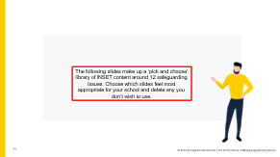 | [This slide is a reminder to choose from the following selection of specific forms of abuse and safeguarding issues. Delete this slide, and any others you don’t wish to cover, before carrying out this training.]  If you’re unsure which safeguarding issues to cover, you may wish to consider:  - Recent safeguarding incidents in your school  - Safeguarding issues that are particularly prevalent in your local area (your LA may be able to help with this if you’re unsure)  - Which safeguarding issues staff have been trained on more recently, and which safeguarding issues may be more in need of a ‘refresher’  - How much time you have available for this INSET training
66 | 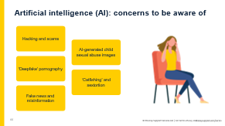 | Safeguarding issue 1: online safety (AI and sextortion)  - Generative AI takes a written prompt and runs it through an algorithm to generate new, ‘natural’-seeming content. Tools include:  - Chatbots such as ChatGPT, Google Gemini and GrammarlyGO, which generate text  - Text-to-image programs like DALL-E and Midjourney, which create images  - Explain to staff that AI is a tool that can impact other safeguarding issues, like child sexual exploitation and sextortion  - Rather than being its own issue with its own signs to spot, staff should be aware of how AI might be used in other safeguarding concerns (e.g. cyber-bullying or sextortion)  - AI can also be used by other children to facilitate child-on-child abuse  - Select to reveal each of the issues, and explain what they are  - Hacking and scams – text generation tools can write convincing emails and text messages to trick pupils into giving malicious actors access to their accounts  - AI-generated child sexual abuse images – some text-to-image tools could be used to create child sexual exploitation material for sexual gratification or as a means of bullying another pupil  - ‘Deepfake’ pornography – super-imposing a person’s face into pornographic videos for sexual gratification or to humiliate the person being put in the images. AI technology is used to alter the person’s facial expressions to make the video look more convincing  - ‘Catfishing’ and sextortion – criminals can use AI-generated profile pictures to appear younger than they are to befriend and groom children and young people, and then solicit information and/or images from them (e.g. nude or semi-nude photos)  - Fake news and misinformation – text-to-image tools can be used to create convincing fake photos of world events, which could be used to promote certain beliefs (including hateful ones)  - Remind staff that AI technology is developing rapidly – the tools will only become more sophisticated over time (e.g. more convincing images, AI-generated videos)
67 | 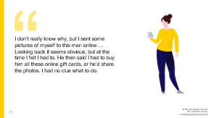 | Safeguarding issue 1: online safety (AI and sextortion) [continued]  - Tell staff to read the quote on the slide  - Explain to staff that:  - Financially motivated sexual extortion is commonly referred to as ‘sextortion’  - It’s when an adult threatens to release nudes or semi-nudes of a child unless they pay money or do something to benefit them  - It’s often carried out by organised crime groups, motivated by profit  - These groups tend to:  - Coerce the child into sending nudes to blackmail them  - Use images stolen from the child through hacking their account  - Use digitally manipulated images, such as AI-generated images  - Tell staff:  - Make sure you take any disclosures seriously, as the child is likely to be embarrassed and worried about the consequences  - Remember: do not intentionally view any nude or semi-nude images  - If you are aware of an incident, report it to your DSL as soon as possible  - [If you covered the slides on online safety in the previous section, invite staff to think back to these earlier slides and the signs to look out for which could suggest a child is being abused online.]  - [If you didn’t cover these slides then use the following list to help staff spot safeguarding issues that could be taking place online.]  - Explain that staff may notice the following signs of abuse being carried out online:  - The child may be spending more time online, or more time offline. This might be reported by their parents. They might complain of being tired because they were online all night, or have their phone going off a lot  - They could have stronger emotional responses or outburst to being online – for example, the child may get unusually angry, upset or distant after checking their phone or using their computer/tablet  - Being secretive about their use of the internet or a device – they may refuse to hand their phone in if it’s part of school policy, or refuse to tell you what they get up to online  - The more general signs of sexual abuse that we saw earlier could indicate a child is being sexually abused online  - If a child tells you that they use their device unsupervised – for example, they play on their iPad when they go to bed – this could be a red flag  - As with other safeguarding issues, staff should always look for changes in behaviour or mood. Although a change might not suggest a child is being abused online, the DSL will look into the situation further
68 | 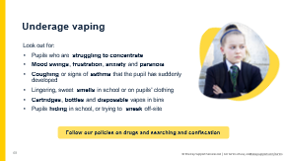 | Safeguarding issue 2: underage vaping  - Tell staff that the next issue you’ll be looking at is underage vaping  - Vaping is using an electronic or e-cigarette (a ‘vape’). Vapes are filled with a liquid known as e-liquid, e-juice or vape juice. The vape heats the liquid until it becomes a vapour, which is then breathed in  - The liquid comes in a variety of ‘flavours’ that might appeal to children (e.g. berry, cola, mint)  - Aside from the health and nicotine addiction risks, pupils may be at risk of consuming vape products containing other drugs such as:  - THC (the psychoactive ingredient in cannabis)  - Spice (a synthetic drug made to mimic cannabis)  - Explain that there are also some safeguarding concerns associated with vaping. As it’s illegal for anyone under 18 to buy vapes, pupils may ask adults to buy vapes for them, or buy them directly from a dealer. These adults could coerce them into sexually abusive situations, or involve them in ‘county lines’ gangs – especially if the pupils become addicted to nicotine  - Explain to staff that the bullets on the slide are things they can look out for:  - Pupils who are struggling to concentrate  - Mood swings, frustration, anxiety and paranoia  - Coughing or signs of asthma that the pupil has suddenly developed  - Lingering, sweet smells in school or on pupils’ clothing  - Cartridges, bottles and disposable vapes in bins  - Pupils hiding in school, or trying to sneak off-site  - If they suspect a pupil may have e-cigarettes on them, they need to follow your policy on searching and confiscating, making sure to put safeguarding first  - Remind staff that only the headteacher and members of staff authorised by the headteacher have the power to search a pupil for a prohibited or banned item, regardless of whether the pupil agrees*  * Even though common law sets out that any staff member can conduct a search with the pupil's permission, it's best practice to only allow staff members who have been authorised by the headteacher to conduct searches. Check your policy and follow what’s in there.
69 | 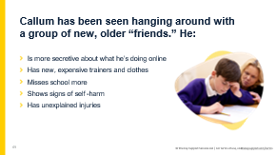 | Safeguarding issue 3: child criminal exploitation (CCE)  [In advance, prepare to briefly explain your local procedures for managing risks associated with criminal exploitation and serious violence.]  Callum has been distant from his old friends, and instead has been seen hanging around with a new group after school. They’re all older than him. As well as this, there have been some other changes:  - Select to bring up the first bullet. Callum is more secretive about what he does online, especially on his phone. He’s been caught on it a few times in class and gets angry when it’s confiscated  - Select to bring up the second bullet point. Callum comes from a low-income background, so his “friends” have helped him out with some nice new clothes and trainers  - But eventually, the “friends” say Callum needs to repay them – they’ve looked after him, now it’s his turn, right?  - Select to bring up the third bullet point. Callum is more likely to start missing school at this point, as he transports or sells drugs. He doesn’t do homework and struggles when he is in school  - Select to bring up the fourth bullet point. He might seem down or more anxious and fearful, due to the effects of what’s happening to him on his mental health. He might self-harm  - Select to bring up the last bullet point. He might have injuries too – his “friends” are violent towards him as a way of intimidating him. He might have other injuries you can’t see, such as from sexual abuse or being made to carry drugs inside his body  - Ask staff again: is Callum a victim or a perpetrator here?  - Although it may appear that children are choosing to participate in crime, they’re being exploited, and potentially physically and sexually abused, and so are still victims  - Once involved, they’re often intimidated into staying through the threat of violence against them and their families, or by ‘drug debts’  - They might also be coerced into carrying a weapon, or start carrying one for their own protection  - Tell staff that Callum is a victim of child criminal exploitation (CCE)  - Explain what child criminal exploitation is:  - It’s where an individual or group takes advantage of an imbalance in power to coerce, manipulate or deceive a child into criminal activity, similar to child sexual exploitation (CSE)  - Age is the most obvious imbalance, but it could also be related to gender, sexual identity, cognitive ability, physical strength or status  - The most well-known form of CCE is ‘county lines’, where children are exploited into transporting and selling drugs. Other forms of CCE can include children being forced or manipulated into working in cannabis factories, shoplifting, pickpocketing, or committing vehicle crime or serious violence  - The slide shows the main signs to look out for that a child might be involved in serious violence or criminal exploitation  - Highlight:  - Girls can be victims too, but their experience can be very different to that of boys  - Having a special educational need (SEN) or living in poverty can make a child more vulnerable to being exploited  - Children involved in criminal exploitation may also be at higher risk of sexual exploitation  - Briefly explain your local procedures for managing the risks of criminal exploitation and serious violence
70 | 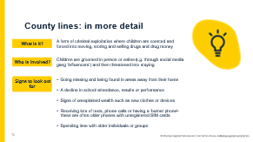 | Safeguarding issue 4: county lines  - Explain that one particular form of child criminal exploitation (CCE) is ‘county lines’ – and if relevant, that it’s something particularly prevalent in your area  - Ask the room for their definitions of county lines and take some ideas before revealing the definition on the slide  - Select to reveal the first section on the slide. County lines is a form of criminal exploitation where children are coerced and forced into moving, storing and selling drugs and drug money. It’s where illegal drugs are transported from one area to another, often across police and LA boundaries. It’s usually done by children who are coerced into moving and storing drugs and drug money. The ‘lines’ refer to the mobile phone line used to take the orders of drugs  - Select to reveal the second section on the slide. Children can be targeted and recruited in different ways, through connections within siblings or schools, or using social media, such as through recruitment adverts designed to target children. They’re then trapped, as county lines gangs create drug debts which need to be worked off, or they threaten serious violence towards victims and their families  - Select to reveal the final section on the slide. If you covered the previous CCE slide, tell staff to think back to Callum’s story, which showed us the signs of a child who’s being drawn into criminal exploitation. If you didn’t cover the CCE slides, discuss what particular signs there might be of children who have been exploited into county lines. They may:  - Go missing and be found in areas away from their home  - Have a decline in school attendance, results or performance  - Have signs of unexplained wealth such as money, clothes, devices or things you wouldn’t expect them to be able to afford  - Receive lots of texts, phone calls or have a ‘burner phone’ – these are often older phones with unregistered SIM cards  - Spend time with older individuals or groups  - Have other changes in behaviour, such as self-harm or changes in emotions
71 | 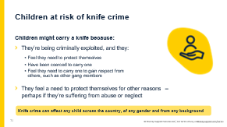 | Safeguarding issue 5: knife crime  Tell staff that incidents of children using knives has been in the news a lot the past couple of years.  What do staff need to know?  - Explain that we should take a child-centred approach and prioritise safeguarding a child involved with knife crime or violence – report any concerns to the DSL, who can help to understand the ‘why’ behind the situation  - Children don’t typically carry knives without a reason  - It could be due to criminal exploitation – for example, where a child:  - Feels they need to protect themselves  - Has been coerced to carry one  - Feels they need to carry one to gain respect from others, such as other gang members  - Sometimes children carry knives as they feel a need to protect themselves for other reasons – perhaps if they’re suffering from abuse or neglect  - Emphasise that knife crime can affect any child across the country, not just within cities. It can also affect children of any gender and any background. It’s important that as a school you’re aware of your local context and any hotspots for violence  - Signs to keep an eye out for:  - Signs of CCE, as there could be a risk a child is carrying a weapon. Keep an eye out for changes such as:  - Changes in behaviour (e.g. being more aggressive or withdrawn)  - Missing school  - Hanging out with new friends  - Unexplained injuries  - If a child is carrying a knife, they might be secretive or protective about their belongings, such as their school bag or blazer  - If staff suspect a pupil has a knife in school:  - Follow our procedures [briefly list what your procedures are]  - If anyone is in immediate danger, call 999  - Speak to the DSL and headteacher immediately  - If a pupil tells you they’ve witnessed a knife-crime incident:  - Listen, be supportive and take them seriously (this is the same for any safeguarding issues or concern a child brings to you)  - Treat it as a disclosure, and follow our child protection policy  - Let our DSL (or deputy) know as soon as possible  [Optional extra detail] What can staff do to support a child? Explain that they can:  - Make all pupils feel connected and as valued members of the school community – this can include just being friendly, welcoming pupils in the morning and chatting to them  - Remind them your school is a place of safety, and they can talk to a trusted adult if they ever need to – it’s never too late to ask for help or support
72 | 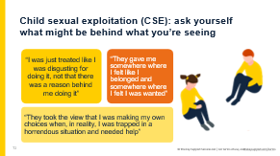 | Safeguarding issue 6: child sexual exploitation (CSE)  - Explain that the next issue you’re going to look at is child sexual exploitation (CSE)  - Tell staff the slide shows some quotes taken or adapted from pen portraits in a report on child sexual exploitation by the Independent Inquiry into Child Sexual Abuse  - These quotes show the feelings and very real experiences of children who have been victims  - Explain:  - CSE is a form of child sexual abuse. It’s when an individual or group takes advantage of an imbalance of power to coerce, manipulate or deceive a child into sexual activity  - It may be in exchange for something the victim needs or wants, like affection, gifts, alcohol or drugs, or for financial advantage  - Age is the most obvious power imbalance, but it could also be related to gender, sexual identity, cognitive ability, physical strength or status  - It can be a one-off occurrence, or a series of incidents over time  - It can happen online, offline, or both  - It can be opportunistic, or complex, organised abuse  - It can happen to both girls and boys, and can be done by both adult males or females, as individuals or in groups  - Although CSE might appear to be consensual, it isn’t  - Children might not realise they’re being exploited. For example, they might believe they’re in a relationship with their abuser, as they don’t necessarily know what a healthy relationship looks like  - They might be too scared to tell anyone, or have been threatened with violence if they do  - Even if a child is 16 or 17, and can legally consent to have sex, they can still be a victim  - Highlight:  - Children with disabilities and children who are LGBTQ+ can be more vulnerable to sexual exploitation. As you noted earlier, they may be at greater risk of harm  - Children from ethnic minority backgrounds face additional barriers to telling someone about their abuse
73 | 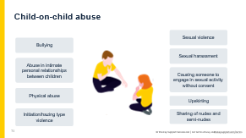 | Safeguarding issue 7: child-on-child abuse  - Explain that child-on-child abuse can take many forms. Select to show each type on the slide, and explain as you go:  - Bullying, including cyber-bullying and prejudice-based and discriminatory bullying – for example, bullying because of a child’s gender identity or perceived sexuality  - Abuse in intimate personal relationships between peers. This is sometimes known as teenage relationship abuse, but can also happen in older primary-aged pupils  - Physical abuse – for example, hitting, kicking, shaking, biting, hair pulling  - Initiation or hazing-type violence and rituals – this includes activities involving harassment, abuse or humiliation, used as a way of initiating someone into a group  - Sexual violence – this could be rape, assault by penetration, or sexual assault  - Sexual harassment, including sexual comments and jokes, and online sexual harassment  - Causing someone to engage in sexual activity without consent – this could include forcing someone to strip, touch themselves sexually, or to engage in sexual activity with a third party  - Upskirting – this is where someone takes a photo under another person’s clothes without their permission, for sexual gratification, or to cause the victim humiliation, distress or alarm  - Sharing nude and semi-nude images or videos. This is sometimes known as sexting or youth-produced sexual imagery  - Note that many of these behaviours can take place online – including non-consensual sharing of sexual imagery; abusive, harassing and misogynistic or misandrist messages; and sharing of abusive images or pornography to those who don’t want to receive this kind of content  - Staff should always assume it’s happening here, even if there aren’t any reports of it. This ties into a key point that we covered at the start: that staff should always maintain an attitude of ‘it could happen here’
74 | 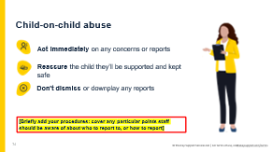 | Safeguarding issue 7: child-on-child abuse [continued]  [In advance, edit this slide to briefly add your procedures for reporting possible child-on-child abuse, including who to report to and how.]  - Explain that staff might witness child-on-child abuse between pupils, or a pupil might tell them they’ve been a victim of child-on-child abuse  - Staff might also see signs that something is wrong, such as the common behavioural signs we looked at earlier. They should always be alert to changes in a child, such as in their mood, behaviour or school performance  - While anyone can be affected, staff should be aware that:  - It’s more likely to be girls as the victim of sexual violence and sexual harassment, and boys more likely to be the perpetrators  - Children with SEN are 3 times for likely to be abused by their peers  - Whether a child makes an allegation or staff see something that’s a cause for concern, staff should always take immediate action, following your school’s policies and procedures  - If a child does make an allegation, staff should reassure the child that they’ll be supported and kept safe. Don’t make the child feel like they’re causing trouble by speaking up  - Staff shouldn’t dismiss an allegation as banter, part of growing up, ‘having a laugh’ or ‘boys being boys’. Doing this can create a culture of unacceptable behaviours and an unsafe environment for children. It can normalise abuse, leading to children accepting it as normal and not reporting it  - Explain that while the victim must always be the priority in any case of child-on-child abuse, schools must still balance between providing appropriate support and taking disciplinary action of the alleged perpetrator – they aren’t mutually exclusive
75 | 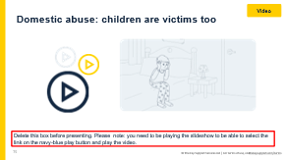 | Safeguarding issue 8: domestic abuse and parental conflict  [Please note: you need to be playing the slideshow to be able to select the link on the navy-blue play button and play the video. This video explains, through illustrations and voiceovers, how children are also victims of domestic abuse, what staff might see in school, and what they should do if a child tells them about domestic abuse.]  - Domestic abuse can be physical, sexual, financial, psychological or emotional. It can happen through technology too – for example, image-based abuse, or using technology to harass, monitor or control the victim, or control their accounts. This is particularly common among young people  - Children can be victims of domestic abuse. They may see, hear, or experience the effects of abuse at home and/or suffer domestic abuse in their own intimate relationships (teenage relationship abuse)  - Note that challenging family circumstances, including growing up with domestic abuse, can make a child more vulnerable to abuse, as you saw in an earlier slide  - Tell staff we’re now going to watch a video, which covers how children are also victims, and what we might see in school  - If any of your staff have a hearing impairment, let them know they can read the transcript for the audio of this video in the document you provided ahead of time  - Play the video (1:57)  - Reiterate that staff should report any concerns they have  - They shouldn’t worry about it not being their business or it being a family matter – these children are still victims and we have a duty to help them  - Video source: https://vimeo.com/715126891/d3183850d9
76 | 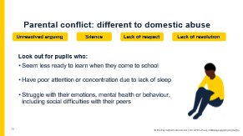 | Safeguarding issue 8: domestic abuse and parental conflict [continued]  - If you covered changes to Working Together to Safeguard Children (WTTSC) earlier on, tell staff to think back to this section  - Explain that WTTSC says that everyone working with children and families has appropriate training to help them understand their role in identifying emerging safeguarding problems. Part of this is having an understanding of domestic abuse and parental conflict that is frequent, intense, and unresolved  - Emphasise that parent conflict is often a normal part of everyday life and isn’t always bad. Harmful parental conflict is a pattern of damaging behaviour  - Explain that conflict can become a safeguarding concern if it’s frequent, intense, poorly resolved or damaging, as this can have a significant negative impact on children’s mental health and long-term life chances  - Ask staff what they think parental conflict might look like. Take 1 or 2 answers from staff. Select to bring up the text on the slide, and explain that it can look like:  - Unresolved arguing  - Silence  - Lack of respect  - Lack of resolution  - It’s understandable that certain periods are more stressful for families, and they’ll likely need more support. For example:  - Bereavement  - A new baby  - Children starting a new school  - Separation or divorce  - Periods of financial difficulty  - Although it won’t always be the case, these can increase the likelihood of harmful conflict  - Parents may also experience drug or substance abuse, and mental health problems which can contribute to conflict  - Select to bring up the final points on the slide. As with other safeguarding issues, staff are well placed to spot signs of concern and are often the first professionals to see the signs that children are being affected by damaging conflict at home. They should look out for children who:  - Seem less ready to learn when they come to school  - Have poor attention or concentration due to lack of sleep  - Have emotional or behavioural problems, including social difficulties with their peers
77 | 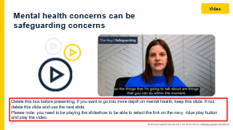 | Safeguarding issue 9: mental health  [If you want to cover mental health, decide whether you want to show the video in this slide (more in-depth), or talk through the next 2 slides (less in-depth). If you used the in-depth slide last year, you may want to refresh staff with the less in-depth slides this year. Delete this slide if you’re not using the video at your safeguarding INSET. Please note: you need to be playing the slideshow to be able to select the link on the navy-blue play button and play the video. In advance, prepare to remind staff of your procedures for reporting concerns about pupils’ mental health.  This video starts with a story about how poor mental health can affect children and gives some context to the issue. It then covers what staff should look out for, and finishes with an expert talking about what school staff can do.]  Remind staff that mental health is part of safeguarding  - Explain that mental health needs can be an indicator of a child suffering abuse, neglect or exploitation, or that a child is at risk – remind staff about the earlier slide where you saw that children with mental health needs are more vulnerable  - Give staff 2 minutes in their groups to discuss:  - What they would do if a child came to talk to them about their mental health  - What kinds of things would they say?  - What support would they give?  - They can make notes in section 4 of their activity packs  - Play the video (4:55)  - Give staff 3 minutes in their groups to discuss:  - What might I do differently having watched this video?  - They can make notes in section 4 of their activity packs  - Remind staff that only trained professionals can make a diagnosis, but as school staff, they’re well placed to spot signs that something might be wrong  - If they're concerned, they should take immediate action and report their concerns, following your procedures. If it's also a safeguarding concern, they should speak to you (the DSL)  - Remind staff that the KCSIE definition of safeguarding includes preventing impairment to children’s health or development, so any concern about mental health is likely to be a safeguarding concern too  - Remind staff of any key points to be aware of in your procedures for reporting mental health concerns, which differ from your procedures for reporting safeguarding concerns
78 | 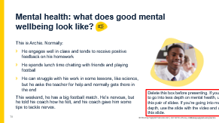 | Safeguarding issue 9: mental health  [Delete this slide if you’re going into more depth and using the video instead. In advance, prepare to remind staff of your procedures for reporting concerns about pupils’ mental health.]  - Remind staff that mental health is part of safeguarding  - Explain that mental health needs can be an indicator of suffering abuse, neglect or exploitation, or that a child is at risk – remind them about the earlier slide where you saw that children with mental health needs are more vulnerable  - Remind staff that only trained professionals can make a diagnosis, but as school staff, they’re well placed to spot signs that something might be wrong  - [Select the audio icon to listen to the scenario, Alternatively, you can read the slide out yourself.] Explain that this is an example of Archie with good mental wellbeing. What signs might we spot if Archie had poor mental health or wellbeing? Give staff 2 or 3 minutes to discuss and take some answers
79 | 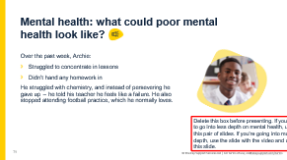 | Safeguarding issue 9: mental health [continued]  [Delete this slide if you’re going into more depth and using the video instead. In advance, prepare to remind staff of your procedures for reporting concerns about pupils’ mental health.]  - [Select the audio icon to listen to the scenario, Alternatively, you can read the slide out yourself.] Explain to staff that these could be signs Archie is struggling with his mental health or wellbeing  - The main thing to look out for is a change in behaviour, mood or appearance  - Poor mental wellbeing or mental ill health can present in many different ways. This isn’t an exhaustive list, but changes indicative of mental ill health could look like:  - Being withdrawn  - Being angry or irritable, or a different change in mood such as being hyperactive  - Physical symptoms, such as feeling sick, sweaty and shaking  - A change in eating habits (losing appetite, not eating)  - Struggling to concentrate in class, loss of focus  - Changes in school performance or attendance  - Loss of motivation  - Feeling tired  - Self-harm  - Many of these symptoms could be explained by issues that aren’t linked to mental health, and could be signs of other safeguarding issues such as abuse. The key thing is to notice a change, and make sure staff act on it. As we mentioned before, staff are well placed to observe children day-to-day and identify any risks.  - If staff are concerned, they should take immediate action and report their concerns, following your procedures. If it's also a safeguarding concern, they should speak to you (the DSL)  - Remind staff of any key points to be aware of in your procedures for reporting mental health concerns, which differ from your procedures for reporting safeguarding concerns
80 | 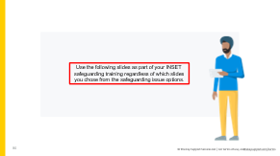 | [This slide highlights the end of the optional SSI slides. Delete this slide before carrying out this training.]
81 | 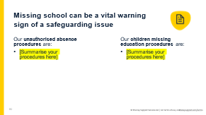 | [In advance, edit this slide to summarise your school’s absence procedures.]  - Explain to staff what the 2 following terms mean:  - Children missing education: a child missing education is a child of compulsory school age who is not registered at a school or receiving a suitable education elsewhere  - Children absent from education: a child who is absent from education is a child on roll at a school, but who is regularly not attending. Persistent absence is defined as a pupil missing 10% or more of school, and severe absence is missing 50% or more of school  - Explain that being absent from education, and missing education, are vital warning signs of safeguarding risks to a child  - It could indicate that a child is being abused or neglected, or that a child is being sexually or criminally exploited (particularly for county lines)  - It might also indicate that a child has mental health problems, or is at risk of:  - Substance abuse  - Travelling to conflict zones  - Female genital mutilation (FGM)  - Honour-based abuse or forced marriage  - Exploitation  - Early intervention is essentials to identify any underlying safeguarding risks and help to prevent children who are absent from becoming a child missing education in the future  - Being absent from education could also increase known safeguarding risks within the family or in the community  - Explain to staff that they need to be aware of your school’s unauthorised absence procedures and children missing education procedures
82 | 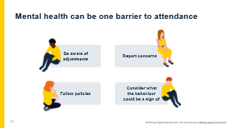 | [In advance, be ready to explain where staff can find any information about adjustments made for pupils struggling with their attendance.]  - Explain to staff that pupils with long-term mental health challenges often have complex barriers to attendance  - If a pupil is struggling with their mental health, it can be 2 steps forward, 3 steps back. As a school, you need to recognise any small successes, and that those 2 steps forward are significant. There's no magic wand to fix attendance, especially for pupils who are struggling with their mental health  - Recognise that it can be difficult for staff who are dealing with pupils struggling with their mental health, and if they ever need to take a step back, they should talk to their line manager, attendance lead or DSL (whichever is appropriate for your setting) for support  - Select to bring up the first bubble. To help pupils struggling with their attendance, staff should be aware of any adjustments that have been made for pupils to help them attend school. For example:  - A child experiences significant anxiety in maths, so you allow them to work alone during maths lessons in a different classroom  - A child experiences sensory overload from school uniform, so you allow them to wear their own top  - Emphasise that this is important to help pupils with their attendance. For example, if an anxious pupil has an arrangement where they can always sit by the door and a cover teacher doesn’t know, that can make the child feel unsafe and not want to attend  - Tell staff where they can find this information for pupils. For example, it could be on their MIS profile, or flagged in teachers’ planners  Staff should also:  - [Select to bring up the second bubble] Follow your policies and procedures for supporting pupils and setting expectations for attendance  - [Select to bring up the third bubble] Report concerns so that underlying issues can be investigated and addressed  - [Select to bring up the final bubble] Consider what the behaviour concerns could be a sign of. For example, if a pupil is misbehaving in class, or walking the corridors and truanting lessons, it might be a signal that they are feeling anxious about school. In this case, the pupil’s form tutor or head of year (or trusted adult) should talk to the pupil and identify the cause of that anxiety, rather than assuming that the behaviour is simply defiance
83 | 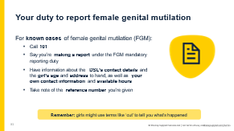 | - Explain that in addition to reporting safeguarding concerns to you (the DSL), teachers have a legal duty to personally report known cases of female genital mutilation (FGM) on girls under 18 to the police  - If the staff member is not a teacher, they still have a duty to report cases of FGM to you (the DSL), as part of your safeguarding responsibilities  - Remind staff that FGM is a procedure which involves partial or total removal of external female genitalia, or other injury to the female genital organs. It is illegal in the UK, whether it happens here or abroad. Emphasise that it is child abuse  - When does it happen? FGM often happens overseas, but it may happen to girls in the UK as well. Children are likely to be taken abroad at the start of the school holidays, especially in the summer, to give the child longer to ‘heal’ before school starts. The age at which it happens is different for different communities – it could be when the girl is new-born, during childhood, at marriage or during a first pregnancy  - Why does it happen? It’s a form of so-called ‘honour’-based abuse, where crimes are committed to protect or defend the honour of the family and/or community. Other types of honour-based abuse include forced marriage and breast ironing or flattening, where breasts are ‘ironed’ or flattened down over a period of time to make them disappear or delay their development. Families might believe FGM is beneficial to the girl or in her best interests, but there are no benefits to it. It can cause serious harm, such as pain, infection, bleeding, urinary problems, mental health problems, and later, problems with sex and pregnancy  - Explain to staff that there are signs to look out for:  - Staff should look out for requests for extended holidays, or mention of a ‘special trip’ or a ‘special ceremony’ to become a woman – these can be signs that a girl is going to be a victim of FGM  - If staff report things like this, you might be able to take action to prevent the girl becoming a victim  - A child’s friend might share concerns or tell you about it  - The mandatory reporting duty applies if a girl under 18 informs a teacher that she’s been a victim of FGM, or the teacher sees physical signs that appear to show the girl has been a victim of FGM. Teachers are more likely to have a girl tell them it’s happened to her, as they won’t be physically examining pupils  - Note, the girl might not use the term ‘female genital mutilation’ but instead use terms like ‘cut’ to tell someone what’s happened to her  - Even if a girl is already a victim, staff can get support to help her  - Staff might notice signs like discomfort walking, sitting or standing, or spending longer in the toilet, or the girl trying to ask for help, due to the painful effects of FGM  - If a girl tells a teacher she’s a victim, the teacher must:  - Make the report as soon as possible – best practice is by the end of the next working day. Although the maximum timeframe is a month, they should report much sooner than this  - Call 101. They should be prepared to:  - Explain they’re making a report under the FGM mandatory reporting duty  - Give their name, contact details, times they’ll be available to be called back, role and place of work  - Give the DSL’s name, contact details and place of work  - Give the girl’s name, age or date of birth, and address  - Take a note of the reference number for the call that they’ll be given  - Teachers should be aware that they may need to contribute to any follow-up response – and you (the DSL) will be able to provide support and advice
84 | 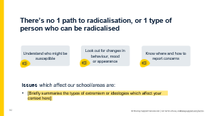 | [In advance, prepare to briefly explain which types of extremism or ideologies affect your school.]  - Tell staff another safeguarding issue where you (as a school) have specific duties is radicalisation, under the Prevent duty  - Explain to staff that when it comes to radicalisation, there’s no 1 path that leads to it or 1 type of person who can be radicalised  - Explain to staff that the Prevent duty says:  - [Select to bring up point 1. Select the audio icon to have the following text read out to your audience. Alternatively, you can read the following out yourself] One of the objectives of Prevent is to intervene early to support people who are susceptible to radicalisation. Children tend to be more easily influenced and impressionable, which can make them more susceptible  - Children who are vulnerable to grooming for sexual exploitation or criminal exploitation may also be vulnerable to radicalisation. Experiencing abuse, bullying, or having personal or emotional difficulties can also make children more susceptible  - [Select to bring up point 2. Select the audio icon to have the following text read out to your audience. Alternatively, you can read the following out yourself] Look out for concerning changes in behaviour, mood or appearance. Explain to staff that, as we know, any changes in behaviour may indicate a safeguarding concern. If a child is being exposed to radicalising influences or drawn into terrorism, they might:  - Have a sudden change in their general behaviour  - Become more argumentative, or suddenly hold strong opinions or values  - Talk in a scripted way  - Refuse to engage with pupils who are different or become abusive towards them  - Embrace conspiracy theories  - Be unwilling or unable to discuss their views  - Show interest in extremists or extreme groups  - Spend a lot more time online or on their phone, which they might become more secretive about  - Access extremist online content and have uncontrolled and unsupervised access to the internet  - [Select to bring up point 3. Select the audio icon to have the following text read out to your audience. Alternatively, you can read the following out yourself] Know where and how to report concerns. Staff should follow your safeguarding policies and procedures, which normally involves reporting concerns to you (the DSL) or your Prevent lead  - [Select to bring up the final section] Briefly summarise for staff some of the issues affecting your local context, such as types of extremism or ideologies which pupils have been exposed to or affected by
85 | 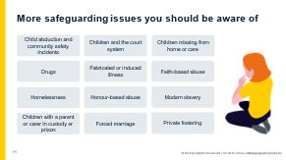 | - Explain that Annex B of KCSIE includes information on specific safeguarding issues. We’ve already covered some of these issues, but not all of them  - All staff who work directly with children are expected to have some knowledge of the issues in Annex B, so they can effectively safeguard children  - Select to bring up the list of specific safeguarding issues that you haven’t already covered, and give staff a moment to read the slide  - Ask staff: how confident are you that you know what all of these are?  - Prompt them to tell you (the DSL) if they're unsure about any of them, so you can give them more information after the session. If staff do ask you about any of these issues, see The Key Safeguarding for more information: https://safeguarding.thekeysupport.com/factsheets-and-briefings/
86 | 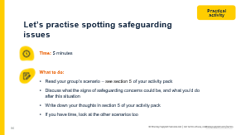 | [For this activity, we recommend 2 to 4 people per group.  Give each group 1 scenario to discuss. There are 8 scenarios in the pack, which link with different issues. If you’ve covered certain issues from this pack, you could pick scenarios for staff with those issues, or pick whatever your staff need most practice with. They are:  - Scenario 1: online safety  - Scenario 2: underage vaping  - Scenario 3: criminal or sexual exploitation  - Scenario 4: child-on-child abuse  - Scenario 5: domestic abuse/parental conflict  - Scenario 6: mental health  - Scenario 7: absent from education  - Scenario 8: radicalisation  When you take feedback, make sure you cover all the scenarios you chose, so staff can hear the answers for each.]  - Tell staff they’re now going to look at some scenarios in their groups to practise spotting potential signs of the safeguarding issues you’ve just talked about  - Putting the learning into practice in a safe environment will help them use it in a real situation later on  - They’re going to look at 1 scenario in their groups. The scenarios are in section 5 of their activity packs  - They have 5 minutes to read the scenario and discuss it  - There’s space for them to write down their thoughts in section 5 of their activity packs  - If they have time, they can look at the other scenarios too  - Make sure staff know which scenario their group is looking at  - When the 5 minutes are up, get everyone back together and move on to the next slide
87 | 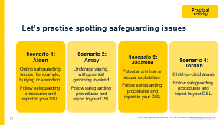 | - Take feedback from 1 group for each scenario  - Once a group has given feedback on their scenario, select to bring up each answer on screen  - For each scenario, confirm and clarify:  - Scenario 1 – Aiden: this change in mood and secretive phone use could suggest Aiden is facing a safeguarding issue online – we don’t know for sure, but he could be facing child-on-child abuse such as cyber-bullying, or he could be facing sexual abuse online, such as sextortion. Staff should report these concerns to you (the DSL), following your school’s procedures – you (the DSL) will be able to support Aiden and find out what is going on  - Scenario 2 – Amoy: vaping underage is a concern. It’s also concerning that she mentioned she gets them for free. Why is she getting them for free, and who is she getting them from? There have been cases in the news of adults using vapes to groom children. This is a safeguarding concern that staff should report following your school’s procedures so you (the DSL) can look into this further  - Scenario 3 – Jasmine: Jasmine has a few changes in her behaviour here, which are signs of concern, so this should be reported to the DSL. Although it’s not entirely clear, missing school, changes in how well she’s doing at school and hanging out with someone older could suggest she’s being criminally or sexually exploited, or even both. Staff should report this to you (the DSL), following your school’s procedures, so you (the DSL) can investigate further  - Scenario 4 – Jordan: this situation looks like it could be bullying. Remember that children with SEN are 3 times more likely to be abused by their peers. Jordan may not realise he is being bullied. If a staff member is one of Jordan’s trusted adults, they may want to talk to him themselves, but they should report this to you (the DSL) following your procedures, so you can find out more  - In all cases, staff should make a report to you (the DSL), or your deputy  - Note, as with the previous scenarios, some of the signs are the same across different types of abuse. The main thing is that staff can spot that something might be wrong. It’s for you (the DSL) to then investigate further to find out what the cause might be
88 | 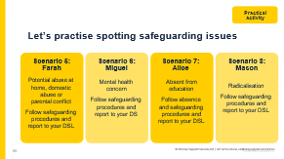 | - Take feedback from 1 group for each scenario  - Once a group has given feedback on their scenario, select to bring up the answer on screen  - For each scenario, confirm and clarify:  - Scenario 5 – Farah: a change in Farah’s behaviour like this suggests a safeguarding concern. Although it could appear like ‘bad behaviour’, seeking attention can be a cause for concern. Saying things that are mature for her age and worrying about going home could suggest a form of sexual abuse happening, or witnessing domestic abuse at home. Staff should report this to you (the DSL) so you can investigate further  - Scenario 6 – Miguel: Miguel’s change in behaviour and mood could be a sign of a safeguarding concern. Miguel could have a mental health concern, but there could also be something else going on. Staff should report this to you (the DSL) following your procedures, so you can support Miguel  - Scenario 7 – Alice: missing school can be a vital warning of a safeguarding issue. Even if staff don’t know why Alice is missing school, they should follow your school’s procedures for unauthorised absences and report this to whoever your procedure says they should report to – it could be you (the DSL) or an attendance lead who will then liaise with the you (the DSL) to support Alice’s attendance  - Scenario 8 – Mason: although we don’t know for sure, this sounds like Mason could be accessing extremist content online. There can be overlap between climate change denial and the alt-right. Even if Mason isn’t accessing extremist content, if he’s using the internet a lot to access this type of information and picking up views so strongly, he could be susceptible to radicalisation. Staff should report this to you (the DSL) so you can assess how to move forward with this situation  - In all cases, staff should make a report to you (the DSL), or your deputy  - Note, as with the previous scenarios, some of the signs are the same across different types of abuse. The main thing is that staff can spot that something might be wrong. It’s for you (the DSL) to then investigate further to find out what the cause might be
89 | 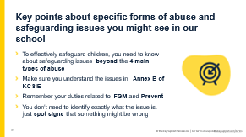 | - Ask staff: what are the key points to take away about specific safeguarding issues?  - Take 1 or 2 suggestions, then select to bring up the points on the slide  - Give staff a minute to read these key points  - Ask if they have any questions about what you’ve covered in this section, and take questions
90 | 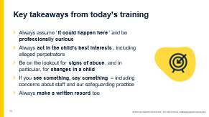 | - Tell staff that you’ve now reached the end of today’s safeguarding INSET  - Round off by recapping the key messages from this training session:  - Always assume ‘it could happen here’ and be professionally curious  - Always act in the child’s best interests  - Be on the lookout for signs of abuse, and in particular, changes in a child  - If you see something, say something – always report any concerns to the DSL or deputy, and keep written records  - Share the staff handouts summarising the key changes to Keeping Children Safe in Education part 1, signs that should always be a cause for concern and how to report safeguarding concerns  - Let staff know that you’ll share the slides afterwards, as well as a link to The Key’s safeguarding assessment (if they’re not completing the paper-based version), which will test their knowledge of Keeping Children Safe in Education part 1. Tell staff that:  - If they get a question wrong, they’ll get prompts to help them get the right answer  - You (the DSL) will be able to access their results to see who’s passed and who still needs to complete the assessment  - Take any final questions  - Thank staff for their continued dedication to keeping children safe in your school
91 to93 |  | - Sources slides

40 to 60 minutes

