Dear School, Parents and Young people,
We are ‘Wash Your Words’ a creative partnership project between Blackpool Library Services and LeftCoast and we presently exploring how we can better engage with 11-16 year olds living and socializing on Mereside in creative projects in the area.
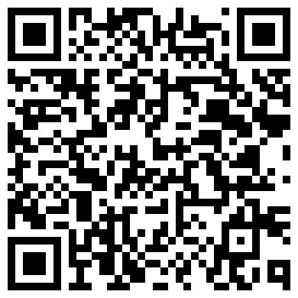
We presently have Mereside ‘innit’ a Learning Playlist of activities and tasks on Blackpool City of Learning which looks to gather young people’s views of Mereside with the aim to create some artwork with the responses. Young people can scan the QR Code to open an account with BadgeCraft and then join the playlist and activities.

In February half term [14th – 17th February] we have a series of afternoon youth tabletop games playing workshops on the Tuesday, Thursday and Friday 1.00PM to 4.00PM. Free refreshments. We will also have Nerdvana (CIC- a local table top games promoters) joining us for one of the sessions. These sessions give us more chances to talk to young people about where they live and introduce to the library, laundry & community space.
If you would like to contact us for more information; either call in to Wash Your Words Langdale Place FY4 4TR or email us on: catherine.peters@leftcoast.org.uk
Many thanks and we look forward to seeing you online or in person soon.
Catherine Peters – Neighbourhood Producer
Buzz Bury – Creative Youth Worker

