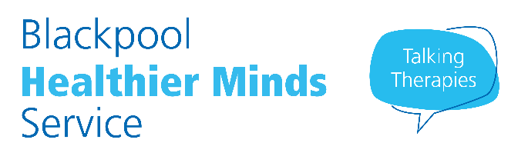

**Free NHS Online 8-week Mindfulness (MBCT) Courses**

Blackpool Healthier Minds NHS Service regularly delivers **FREE online Mindfulness Based Cognitive Therapy** (MBCT) courses.  MBCT combines traditional ***cognitive behavioural therapy*** with ***mindfulness*** techniques and ***meditation*** and teaches you how to pay ***attention to the present moment***, rather than habitually getting caught up in ***ruminating about the past*** or ***worrying about the future*** and ***learning new skills*** to let go of the negative thoughts that can often precede increased stress and distress or a dip in mood.

There are **8 sessions** held on a weekly basis. Each weekly session lasts **for two hours**.  Our courses run throughout the year starting in **January, April, June and September with the LIVE online session at 1.00pm then available to freely access online for the next three days. N.B. There is also a FREE introductory session** before each course starts to help trouble shoot any problems with remote access.

**To sign up for this FREE course please** call: **01253 955700 or** Email us at:bfwh.healthierminds@nhs.net



This course is for complete beginners as well as for those who have had some experience of meditation or mindfulness.  It is currently taught online with no requirement to participate; however, there are opportunities to ask questions. Like any skill, mindfulness takes time to practice, and we highly recommend you set some time aside each day for daily home practice to be able to optimize new skills and make good use of what you learn each week.  You will be emailed links to each session and freely access links to online guided meditations to support your daily practice.

**The Mindfulness course is FREE and is being offered online,**

**courses are available throughout the year.**

To book a place call: **01253 955700 or** Email us at:bfwh.healthierminds@nhs.net

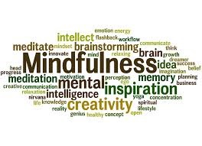**We do not offer 24-hour or weekend access, crisis or urgent treatment, treatment for alcohol or drug problems or treatment for severe and enduring mental illness. Please discuss these needs with your GP.**