**Blackpool Healthier Minds**  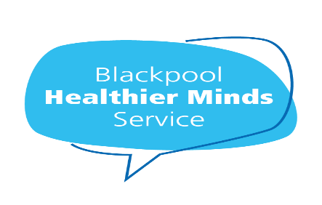

**Blackpool Teaching Hospitals NHS Foundation Trust**

Blackpool Healthier Minds Service is Blackpool's Improving Access to Psychological Therapies (IAPT) service and provided by Blackpool Teaching Hospitals NHS Foundation Trust.

Blackpool Healthier Minds is a free talking therapy service and offers a range of therapy options recommended by the National Institute for Health and Care Excellence (NICE) for common mental health problems such as depression and anxiety. Our service is available to anyone aged 16 or over and registered with a Blackpool or Cleveleys GP.

Available talking therapies include Cognitive Behavioural Therapy (CBT), Counselling, Guided self-help, Eye Movement Desensitisation Therapy (EMDR), Stress control courses, Mindfulness classes and one off webinars focussed on specific issues such as Sleep hygiene, Menopause, Exam stress to name a few.

**To self-refer/general enquiries call**: 01253 955700

**Our website to find out more and register online:** bfwh.nhs.uk/our-services/healthier-minds

**Email us at:** bfwh.healthierminds@nhs.net

**Follow us on Facebook**: @Blackpool Healthier Minds

**Twitter**: @BHealthierMinds