Dear Parent/Carer 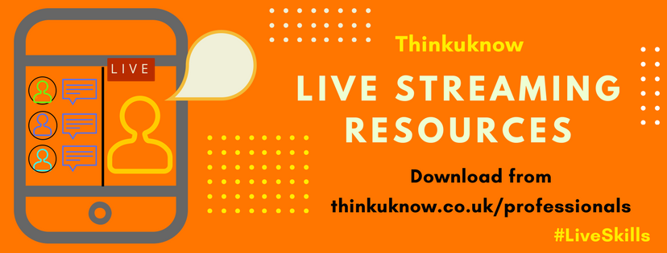

**Your child’s online safety education this term**

This term your child’s class will be studying a unit of work based on using new online technology safely, developing skills in resilience, self-esteem and positive attention seeking behaviour. It has been produced by the National Crime Agency’s child protection education programme [Thinkuknow](http://www.thinkuknow.co.uk/).

About Live Streaming

In particular the Thinkuknow educational activities introduce scenario’s and reflection about ‘Live Streaming’. Live streaming is the broadcasting of real-time, live video to an audience over the internet. All you need to be abl e to live stream is an internet enabled device, like a smart phone or tablet with a camera, and an app that has a ‘Live’ function, such as Instagram Live or Musica.ly.

#Live Skills

To help support children to enjoy live streaming safely, if they are currently doing it, or for those that may be introduced to it when they start secondary school, these educational activities focus on building children’s skills to know who to trust online and how to get affirmation in positive ways at home and school. These skills are important for navigating both the online and offline world.

How you can get involved

* **Schedule planned attention:** One on one time, doing something together that is largely child-directed.
* **Give personal and positive feedback to child**: focus on praising good behaviours more than focussing attention on minor bad behaviours. Specific praise to be emphasised and inclusion of emotions: i.e. You are being such as kind sister sharing the toys with your brother. You are playing with him so gently. I’m sure he feels very happy to be playing with you! Practicing this daily can demonstrates to a child what they are specifically doing well and they know what behaviour to show again.
* **Try and see the learning in mistakes**
* **Be involved in your child’s internet use:** The best learning and the safest children are those who are able to share what they have been doing online with their parents.
* **Be good to yourself**: When children see us being critical of ourselves and our appearance or abilities that becomes normative for them to focus on the things they are doing wrong. It can help to notice when we are doing this and try and focus on the positives of our own lives and actions.
* **Encouraging choice and consent from an early age**: Children are socialised to do as they are told- especially when adults ask. Adults online can exploit this when chatting to children. Giving a child a choice from an early age develops their autonomy and good decision making skills. For example not forcing a child to hug a relative etc. Give them the option to be polite in another way.

Visit [www.thinkuknow.co.uk/parents](http://www.thinkuknow.co.uk/parents) for information and advice to help to keep children safe online